






Prepare and display sugar work
D1.HPA.CL4.03
Trainer Guide

Prepare and display sugar work

D1.HPA.CL4.03

Trainer Guide




Project Base
William Angliss Institute of TAFE
555 La Trobe Street
Melbourne 3000 Victoria
Telephone: | (03) 9606 2111
Facsimile: | (03) 9670 1330
Acknowledgements
Project Director: | Wayne Crosbie
Chief Writer: | Alan Hickman
Subject Writer: | Garry Blackburn
Project Manager: | Alan Maguire
Editor: | Jim Irwin
DTP/Production: | Daniel Chee, Mai Vu, Kaly Quach
The Association of Southeast Asian Nations (ASEAN) was established on 8 August 1967. The Member States of the Association are Brunei Darussalam, Cambodia, Indonesia, Lao PDR, Malaysia, Myanmar, Philippines, Singapore, Thailand and Viet Nam.
The ASEAN Secretariat is based in Jakarta, Indonesia.
General Information on ASEAN appears online at the ASEAN Website: www.asean.org.
All text is produced by William Angliss Institute of TAFE for the ASEAN Project on “Toolbox Development for Front Office, Food and Beverage Services and Food Production Divisions”.
This publication is supported by the Australian Government’s aid program through the ASEAN-Australia Development Cooperation Program Phase II (AADCP II).
Copyright: Association of Southeast Asian Nations (ASEAN) 2013.
All rights reserved.
Disclaimer
Every effort has been made to ensure that this publication is free from errors or omissions. However, you should conduct your own enquiries and seek professional advice before relying on any fact, statement or matter contained in this book. The ASEAN Secretariat and William Angliss Institute of TAFE are not responsible for any injury, loss or damage as a result of material included or omitted from this course. Information in this module is current at the time of publication. Time of publication is indicated in the date stamp at the bottom of each page.
Some images appearing in this resource have been purchased from stock photography suppliers Shutterstock and iStockphoto and other third party copyright owners and as such are non-transferable and non-exclusive. Clip arts, font images and illustrations used are from the Microsoft Office Clip Art and Media Library. Some images have been provided by and are the property of William Angliss Institute.
Additional images have been sourced from Flickr and SKC and are used under Creative Commons licence: http://creativecommons.org/licenses/by/2.0/deed.en
File name: TG_Prepare_&_display_sugar_work_FN_030214





Table of contents
Competency Based Training (CBT) and assessment – An introduction for trainers 1
Competency standard 11
Notes and PowerPoint slides 19
Patisserie practical classes: Recommended training equipment 63
Instructions for Trainers for using PowerPoint – Presenter View 65
Appendix – ASEAN acronyms 67

Competency Based Training (CBT) and assessment – An introduction for trainers

Competency
Competency refers to the ability to perform particular tasks and duties to the standard of performance expected in the workplace.
Competency requires the application of specified knowledge, skills and attitudes relevant to effective participation, consistently over time and in the workplace environment.
The essential skills and knowledge are either identified separately or combined.
Knowledge identifies what a person needs to know to perform the work in an informed and effective manner.
Skills describe the application of knowledge to situations where understanding is converted into a workplace outcome.
Attitude describes the founding reasons behind the need for certain knowledge or why skills are performed in a specified manner.
Competency covers all aspects of workplace performance and involves:
- Performing individual tasks
- Managing a range of different tasks
- Responding to contingencies or breakdowns
- Dealing with the responsibilities of the workplace
- Working with others.

Unit of Competency
Like with any training qualification or program, a range of subject topics are identified that focus on the ability in a certain work area, responsibility or function.
Each manual focuses on a specific unit of competency that applies in the hospitality workplace.
In this manual a unit of competency is identified as a ‘unit’.
Each unit of competency identifies a discrete workplace requirement and includes:
- Knowledge and skills that underpin competency
- Language, literacy and numeracy
- Occupational health and safety requirements.
Each unit of competency must be adhered to in training and assessment to ensure consistency of outcomes.

Element of Competency
An element of competency describes the essential outcomes within a unit of competency.
The elements of competency are the basic building blocks of the unit of competency. They describe in terms of outcomes the significant functions and tasks that make up the competency.
In this manual elements of competency are identified as an ‘element’.

Performance criteria
Performance criteria indicate the standard of performance that is required to demonstrate achievement within an element of competency. The standards reflect identified industry skill needs.
Performance criteria will be made up of certain specified skills, knowledge and attitudes.

Learning
For the purpose of this manual learning incorporates two key activities:
- Training
- Assessment.
Both of these activities will be discussed in detail in this introduction.
Today training and assessment can be delivered in a variety of ways. It may be provided to participants:
- On-the-job – in the workplace
- Off-the-job – at an educational institution or dedicated training environment
- As a combination of these two options.
No longer is it necessary for learners to be absent from the workplace for long periods of time in order to obtain recognised and accredited qualifications.

Learning Approaches
This manual will identify two avenues to facilitate learning:
Competency Based Training (CBT)
This is the strategy of developing a participant’s competency.
Educational institutions utilise a range of training strategies to ensure that participants are able to gain the knowledge and skills required for successful:
- Completion of the training program or qualification
- Implementation in the workplace.
The strategies selected should be chosen based on suitability and the learning styles of participants.

Competency Based Assessment (CBA)
This is the strategy of assessing competency of a participant.
Educational institutions utilise a range of assessment strategies to ensure that participants are assessed in a manner that demonstrates validity, fairness, reliability, flexibility and fairness of assessment processes.

Flexibility in Learning
It is important to note that flexibility in training and assessment strategies is required to meet the needs of participants who may have learning difficulties. The strategies used will vary, taking into account the needs of individual participants with learning difficulties. However they will be applied in a manner which does not discriminate against the participant or the participant body as a whole.
Catering for Participant Diversity
Participants have diverse backgrounds, needs and interests. When planning training and assessment activities to cater for individual differences, trainers and assessors should:
- Consider individuals’ experiences, learning styles and interests
- Develop questions and activities that are aimed at different levels of ability
- Modify the expectations for some participants
- Provide opportunities for a variety of forms of participation, such as individual, pair and small group activities
- Assess participants based on individual progress and outcomes.
The diversity among participants also provides a good reason for building up a learning community in which participants support each other’s learning.
Participant Centred Learning
This involves taking into account structuring training and assessment that:
- Builds on strengths – Training environments need to demonstrate the many positive features of local participants (such as the attribution of academic success to effort, and the social nature of achievement motivation) and of their trainers (such as a strong emphasis on subject disciplines and moral responsibility). These strengths and uniqueness of local participants and trainers should be acknowledged and treasured
- Acknowledges prior knowledge and experience – The learning activities should be planned with participants’ prior knowledge and experience in mind
- Understands learning objectives – Each learning activity should have clear learning objectives and participants should be informed of them at the outset. Trainers should also be clear about the purpose of assignments and explain their significance to participants
- Teaches for understanding – The pedagogies chosen should aim at enabling participants to act and think flexibly with what they know
- Teaches for independent learning – Generic skills and reflection should be nurtured through learning activities in appropriate contexts of the curriculum. Participants should be encouraged to take responsibility for their own learning
- Enhances motivation – Learning is most effective when participants are motivated. Various strategies should be used to arouse the interest of participants
- Makes effective use of resources – A variety of teaching resources can be employed as tools for learning
- Maximises engagement – In conducting learning activities, it is important for the minds of participants to be actively engaged
- Aligns assessment with learning and teaching – Feedback and assessment should be an integral part of learning and teaching
- Caters for learner diversity – Trainers should be aware that participants have different characteristics and strengths and try to nurture these rather than impose a standard set of expectations.
Active Learning
The goal of nurturing independent learning in participants does not imply that they always have to work in isolation or solely in a classroom. On the contrary, the construction of knowledge in tourism and hospitality studies can often best be carried out in collaboration with others in the field. Sharing experiences, insights and views on issues of common concern, and working together to collect information through conducting investigative studies in the field (active learning) can contribute a lot to their eventual success.
Active learning has an important part to play in fostering a sense of community in the class. First, to operate successfully, a learning community requires an ethos of acceptance and a sense of trust among participants, and between them and their trainers. Trainers can help to foster acceptance and trust through encouragement and personal example, and by allowing participants to take risks as they explore and articulate their views, however immature these may appear to be. Participants also come to realise that their classmates (and their trainers) are partners in learning and solving.
Trainers can also encourage cooperative learning by designing appropriate group learning tasks, which include, for example, collecting background information, conducting small-scale surveys, or producing media presentations on certain issues and themes. Participants need to be reminded that, while they should work towards successful completion of the field tasks, developing positive peer relationships in the process is an important objective of all group work.

Competency Based Training (CBT)
Principle of Competency Based Training
Competency based training is aimed at developing the knowledge, skills and attitudes of participants, through a variety of training tools.
Training Strategies
The aims of this curriculum are to enable participants to:
- Undertake a variety of subject courses that are relevant to industry in the current environment
- Learn current industry skills, information and trends relevant to industry
- Learn through a range of practical and theoretical approaches
- Be able to identify, explore and solve issues in a productive manner
- Be able to become confident, equipped and flexible managers of the future
- Be ‘job ready’ and a valuable employee in the industry upon graduation of any qualification level.
To ensure participants are able to gain the knowledge and skills required to meet competency in each unit of competency in the qualification, a range of training delivery modes are used.
Types of Training
In choosing learning and teaching strategies, trainers should take into account the practical, complex and multi-disciplinary nature of the subject area, as well as their participant’s prior knowledge, learning styles and abilities.
Training outcomes can be attained by utilising one or more delivery methods:
Lecture/Tutorial
This is a common method of training involving transfer of information from the trainer to the participants. It is an effective approach to introduce new concepts or information to the learners and also to build upon the existing knowledge. The listener is expected to reflect on the subject and seek clarifications on the doubts.
Demonstration
Demonstration is a very effective training method that involves a trainer showing a participant how to perform a task or activity. Through a visual demonstration, trainers may also explain reasoning behind certain actions or provide supplementary information to help facilitate understanding.
Group Discussions
Brainstorming in which all the members in a group express their ideas, views and opinions on a given topic. It is a free flow and exchange of knowledge among the participants and the trainer. The discussion is carried out by the group on the basis of their own experience, perceptions and values. This will facilitate acquiring new knowledge. When everybody is expected to participate in the group discussion, even the introverted persons will also get stimulated and try to articulate their feelings.
The ideas that emerge in the discussions should be noted down and presentations are to be made by the groups. Sometimes consensus needs to be arrived at on a given topic. Group discussions are to be held under the moderation of a leader guided by the trainer. Group discussion technique triggers thinking process, encourages interactions and enhances communication skills.
Role Play
This is a common and very effective method of bringing into the classroom real life situations, which may not otherwise be possible. Participants are made to enact a particular role so as to give a real feel of the roles they may be called upon to play. This enables participants to understand the behaviour of others as well as their own emotions and feelings. The instructor must brief the role players on what is expected of them. The role player may either be given a ready-made script, which they can memorize and enact, or they may be required to develop their own scripts around a given situation. This technique is extremely useful in understanding creative selling techniques and human relations. It can be entertaining and energizing and it helps the reserved and less literate to express their feelings.

Simulation Games
When trainees need to become aware of something that they have not been conscious of, simulations can be a useful mechanism. Simulation games are a method based on "here and now" experience shared by all the participants. The games focus on the participation of the trainees and their willingness to share their ideas with others. A "near real life" situation is created providing an opportunity to which they apply themselves by adopting certain behaviour. They then experience the impact of their behaviour on the situation. It is carried out to generate responses and reactions based on the real feelings of the participants, which are subsequently analysed by the trainer.
While use of simulation games can result in very effective learning, it needs considerable trainer competence to analyse the situations.
Individual /Group Exercises
Exercises are often introduced to find out how much the participant has assimilated. This method involves imparting instructions to participants on a particular subject through use of written exercises. In the group exercises, the entire class is divided into small groups, and members are asked to collaborate to arrive at a consensus or solution to a problem.
Case Study
This is a training method that enables the trainer and the participant to experience a real life situation. It may be on account of events in the past or situations in the present, in which there may be one or more problems to be solved and decisions to be taken. The basic objective of a case study is to help participants diagnose, analyse and/or solve a particular problem and to make them internalize the critical inputs delivered in the training. Questions are generally given at the end of the case study to direct the participants and to stimulate their thinking towards possible solutions. Studies may be presented in written or verbal form.
Field Visit
This involves a carefully planned visit or tour to a place of learning or interest. The idea is to give first-hand knowledge by personal observation of field situations, and to relate theory with practice. The emphasis is on observing, exploring, asking questions and understanding. The trainer should remember to brief the participants about what they should observe and about the customs and norms that need to be respected.
Group Presentation
The participants are asked to work in groups and produce the results and findings of their group work to the members of another sub-group. By this method participants get a good picture of each other's views and perceptions on the topic and they are able to compare them with their own point of view. The pooling and sharing of findings enriches the discussion and learning process.
Practice Sessions
This method is of paramount importance for skills training. Participants are provided with an opportunity to practice in a controlled situation what they have learnt. It could be real life or through a make-believe situation.

Games
This is a group process and includes those methods that involve usually fun-based activity, aimed at conveying feelings and experiences, which are everyday in nature, and applying them within the game being played. A game has set rules and regulations, and may or may not include a competitive element. After the game is played, it is essential that the participants be debriefed and their lessons and experiences consolidated by the trainer.
Research
Trainers may require learners to undertake research activities, including online research, to gather information or further understanding about a specific subject area.

Competency Based Assessment (CBA)
Principle of Competency Based Assessment
Competency based assessment is aimed at compiling a list of evidence that shows that a person is competent in a particular unit of competency.
Competencies are gained through a multitude of ways including:
- Training and development programs
- Formal education
- Life experience
- Apprenticeships
- On-the-job experience
- Self-help programs.
All of these together contribute to job competence in a person. Ultimately, assessors and participants work together, through the ‘collection of evidence’ in determining overall competence.
This evidence can be collected:
- Using different formats
- Using different people
- Collected over a period of time.
The assessor who is ideally someone with considerable experience in the area being assessed, reviews the evidence and verifies the person as being competent or not.
Flexibility in Assessment
Whilst allocated assessment tools have been identified for this subject, all attempts are made to determine competency and suitable alternate assessment tools may be used, according to the requirements of the participant.
The assessment needs to be equitable for all participants, taking into account their cultural and linguistic needs.
Competency must be proven regardless of:
- Language
- Delivery Method
- Assessment Method.
Assessment Objectives
The assessment tools used for subjects are designed to determine competency against the ‘elements of competency’ and their associated ‘performance criteria’.
The assessment tools are used to identify sufficient:
- Knowledge, including underpinning knowledge
- Skills
- Attitudes
Assessment tools are activities that trainees are required to undertake to prove participant competency in this subject.
All assessments must be completed satisfactorily for participants to obtain competence in this subject. There are no exceptions to this requirement, however, it is possible that in some cases several assessment items may be combined and assessed together.
Types of Assessment
Allocated Assessment Tools
There are a number of assessment tools that are used to determine competency in this subject:
- Work projects
- Written questions
- Oral questions
- Third Party Report
- Observation Checklist.
Instructions on how assessors should conduct these assessment methods are explained in the Assessment Manuals.
Alternative Assessment Tools
Whilst this subject has identified assessment tools, as indicated above, this does not restrict the assessor from using different assessment methods to measure the competency of a participant.
Evidence is simply proof that the assessor gathers to show participants can actually do what they are required to do.
Whilst there is a distinct requirement for participants to demonstrate competency, there are many and diverse sources of evidence available to the assessor.
Ongoing performance at work, as verified by a supervisor or physical evidence, can count towards assessment. Additionally, the assessor can talk to customers or work colleagues to gather evidence about performance.
A range of assessment methods to assess competency include:
- Practical demonstrations
- Practical demonstrations in simulated work conditions
- Problem solving
- Portfolios of evidence
- Critical incident reports
- Journals
- Oral presentations
- Interviews
- Videos
- Visuals: slides, audio tapes
- Case studies
- Log books
- Projects
- Role plays
- Group projects
- Group discussions
- Examinations.
Recognition of Prior Learning
Recognition of Prior Learning is the process that gives current industry professionals who do not have a formal qualification, the opportunity to benchmark their extensive skills and experience against the standards set out in each unit of competency/subject.
Also known as a Skills Recognition Audit (SRA), this process is a learning and assessment pathway which encompasses:
- Recognition of Current Competencies (RCC)
- Skills auditing
- Gap analysis and training
- Credit transfer.
Assessing competency
As mentioned, assessment is the process of identifying a participant’s current knowledge, skills and attitudes sets against all elements of competency within a unit of competency. Traditionally in education, grades or marks were given to participants, dependent on how many questions the participant successfully answered in an assessment tool.
Competency based assessment does not award grades, but simply identifies if the participant has the knowledge, skills and attitudes to undertake the required task to the specified standard.
Therefore, when assessing competency, an assessor has two possible results that can be awarded:
- Pass Competent (PC)
- Not Yet Competent (NYC).
Pass Competent (PC)
If the participant is able to successfully answer or demonstrate what is required, to the expected standards of the performance criteria, they will be deemed as ‘Pass Competent’ (PC).
The assessor will award a ‘Pass Competent’ (PC) if they feel the participant has the necessary knowledge, skills and attitudes in all assessment tasks for a unit.
Not Yet Competent’ (NYC)
If the participant is unable to answer or demonstrate competency to the desired standard, they will be deemed to be ‘Not Yet Competent’ (NYC).
This does not mean the participant will need to complete all the assessment tasks again. The focus will be on the specific assessment tasks that were not performed to the expected standards.
The participant may be required to:
a) Undertake further training or instruction
b) Undertake the assessment task again until they are deemed to be ‘Pass Competent’.

Competency standard
UNIT TITLE: PREPARE AND DISPLAY SUGAR WORK |  |  |  | NOMINAL HOURS: 55
UNIT NUMBER: D1.HPA.CL4.03
UNIT DESCRIPTOR: This unit deals with skills and knowledge required by cooks, chefs and patissiers to prepare, display and store sugar based display pieces in a commercial food production environment
ELEMENTS AND PERFORMANCE CRITERIA | UNIT VARIABLE AND ASSESSMENT GUIDE
Element 1: Prepare sugar for boiling  - Select and weigh ingredients  - Combine ingredients and prepare sugar for boiling  - Collect equipment required to prepare sugar  Element 2: Boil sugar  - Collect equipment required to boil sugar  - Follow specified method of sugar boiling  - Use colours appropriately  - Handle boiled sugar solution safely  Element 3: Pull boiled sugar  - Collect equipment required to pull boiled sugar  - Manipulate boiled sugar  - Store/hold pulled sugar | Unit Variables  The Unit Variables provide advice to interpret the scope and context of this unit of competence, allowing for differences between enterprises and workplaces. It relates to the unit as a whole and facilitates holistic assessment  This unit applies to all industry sectors that are responsible for preparing, displaying and storing sugar work within the labour divisions of the hotel and travel industries and may include:  1. Food Production  Ingredients will include:  Sugar  Water  Glucose  Colouring agents  Calcium carbonate  Cream of tartar.
Element 4: Use pulled sugar to produce display sugar work  - Collect equipment required to produce display sugar pieces  - Produce blown sugar shapes  - Produce ribbons and bows  - Shape sugar pieces into leaves and flowers  - Weave sugar to form baskets  Element 5: Pour boiled sugar to produce cast display sugar work  - Collect equipment required to produce cast display sugar work pieces  - Add specific ingredients to create effects  - Pour and set sugar  - Release sugar from forms  Element 6: Plan sugar display piece  - Plan display piece appropriate to client, occasion or theme able to be produced in time available using a variety of techniques  - Prepare a sketch or outline of display  - Prepare forms and shapes as required by the design  - Calculate quantities required for components of display piece | Equipment may be related to:  Copper pots  Sugar thermometer  Heat proof gloves  Cold water bath  Marble slab  Oil  Pulling hook  Metal, plaster, plasticine and rubber moulds  Mouth or hand pump  Weaving board  Pallet knife/spatula  Heat lamp  Sugar box  Patterns  Scissors  Rubber mats  Foil  Silicone paper.  Manipulate boiled sugar should relate to:  Turn out sugar  Pour sugar
Element 7: Assemble and display sugar work piece  - Assemble sugar work  - Decorate sugar work piece  - Display sugar work piece  Element 8: Store sugar display pieces  - Store according to enterprise and standard industry practice  - Store in appropriate conditions  - Store to maintain maximum quality and appearance | Manipulate sugar  Pull sugar  Standard practices and safety requirements.  Store/hold should include:  Keep warm under lamp  Allow to cool for use later  Re-heat for use  Store moisture free.  Blown sugar shapes may include:  Fruits  Animals  Figures.  Ribbons and bows may relate to:  Preparing colours  Joining colours  Pulling ribbons to required length and width  Joining ribbons  Folding ribbon to form bows.
Leaves and flowers may relate to:
Use of hands or moulds
Produce petals
Produce leaves
Join pieces to form flowers.
Weave sugar may relate to:
Correct temperature
Correct consistency
Preparing weaving frame
Ensuring consistent thickness of weave
Joining sugar
Finishing top and base
Joining handle.
Display piece may include:
Size
Shape
Style
Theme.
Variety of techniques may include:
Blown
Woven
Cast
Blown.
Assemble may relate to:
Using warm sugar to join pieces
Using a heat lamp to melt edges to join pieces
Using royal icing to join pieces.
Decorate may include:
Using warm sugar, piped
Using royal icing.
Display may relate to the use of:
Ceramic
Glass
Mirrors
Wood
Fabric.
Appropriate conditions relates to:
As appropriate to each type of petit fours
Cool
Dry
Moisture free
Low humidity.
Assessment Guide
The following skills and knowledge must be assessed as part of this unit:
Ability to use safe sugar boiling and handling techniques
Knowledge of sugar crystallisation during sugar preparation, boiling and production and prevention methods
Knowledge of the ingredients used and reactions between them
Knowledge of cleanliness in the preparation and production of sugar
Knowledge of commodities
Ability to maintain hygiene and food safety requirements
Ability to maintain safety requirements in relation to the preparation, cooking and handling of hot sugar solutions
Knowledge of historical and cultural aspects of sugar work and its role in the industry and the menu
Ability to use creative and artistic skills in the design, preparation, decoration and display of sugar work
Ability to produce a range of sugar display pieces including casting, pulling, weaving and blowing.
Linkages To Other Units
Comply with workplace hygiene procedures
Implement occupational health and safety procedures
Prepare and store food
Work effectively with colleagues and customers
Present and display food products
Apply basic techniques of commercial cookery
Other food units as appropriate, such as pastry, cakes, yeast goods, desserts, buffet and food service operation.
Critical Aspects of Assessment
Evidence of the following is essential:
Demonstration of commodity knowledge including quality aspects
Demonstrated ability to safely and hygienically handle products
Knowledge of terminology related to sugar work
Demonstrated ability to prepare a variety of sugar pieces for at least two different events or occasions
Demonstration of creative and artistic skills in the preparation, decoration and display of sugar work pieces
Demonstrated ability to store sugar work pieces to industry and enterprise standards.
Context of Assessment
This unit may be assessed on or off the job
Assessment should include practical demonstration either in the workplace or through a simulation activity, supported by a range of methods to assess underpinning knowledge
Assessment must relate to the individuals work area or area of responsibility
Preparation, decoration and display of sugar display pieces with typical workplace conditions and timeframes
Demonstration of skills on more than one occasion.
Resource Implications
Training and assessment must include access and use of a fully equipped commercial kitchen; and use of real ingredients and service equipment; and access to workplace standards, procedures, policies, guidelines, tools and equipment.
Assessment Methods
The following methods may be used to assess competency for this unit:
Observation of practical candidate performance
Oral and written questions
Third party reports completed by a supervisor
Project and assignment work.
Key Competencies in this Unit
Level 1 = competence to undertake tasks effectively
Level 2 = competence to manage tasks
Level 3 = competence to use concepts for evaluating
 | Key Competencies | Level | Examples
 | Collecting, organising and analysing information | 2 | Determine requirements of standard recipes and/or menu requirements; collect equipment, commodities and ingredients; select and obtain commodities; organise ingredients and task sheets
 | Communicating ideas and information | 1 | Share information with other kitchen and floor service staff; read recipes, menus, instructions and orders
 | Planning and organising activities | 2 | Complete preparation mise-en-place and organise for the production of sugar work pieces; work within time constraints in a logical sequence
 | Working with others and in teams | 1 | Work cooperatively with other team members
 | Using mathematical ideas and techniques | 1 | Calculate quantities and portions against standard recipes and/or menu requirements
 | Solving problems | 1 | Identify and correct problems in the preparation and production of sugar work such as ingredient quality
 | Using technology | 1 | Use mechanical kitchen equipment including weighing equipment

Notes and PowerPoint slides
Slide
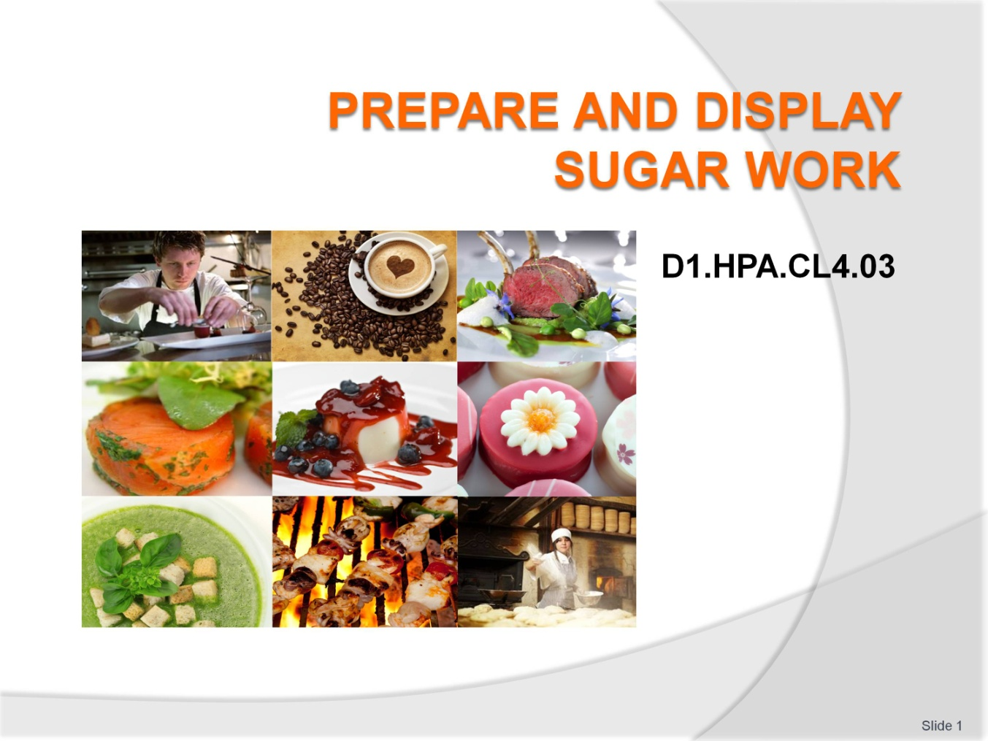
Slide No | Trainer Notes
 | Welcome the Students to the class.

Slide
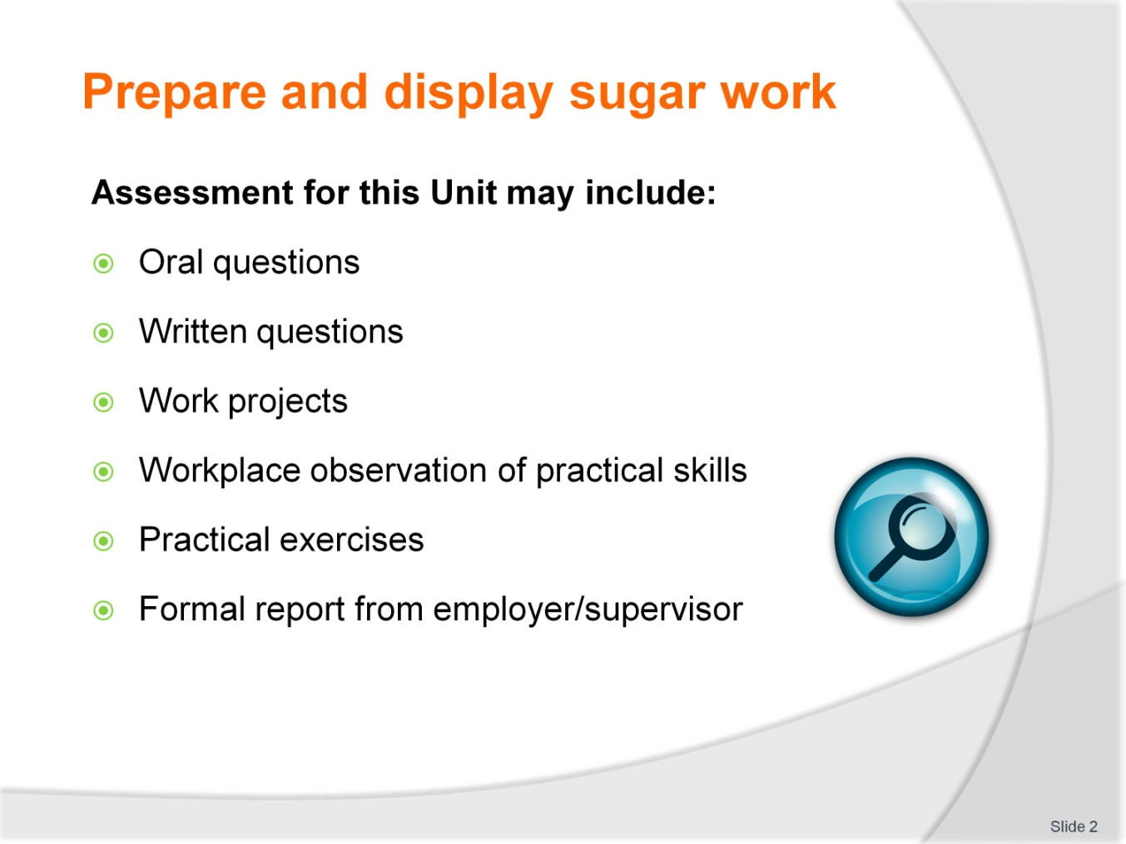
Slide No | Trainer Notes
Trainer to Advise
Trainer advises students that assessment for this Unit may take several forms all of which are aimed at verifying they have achieved competency for the Unit as required.
Trainer indicates to students the methods of assessment that will be applied to them for this Unit.

Slide
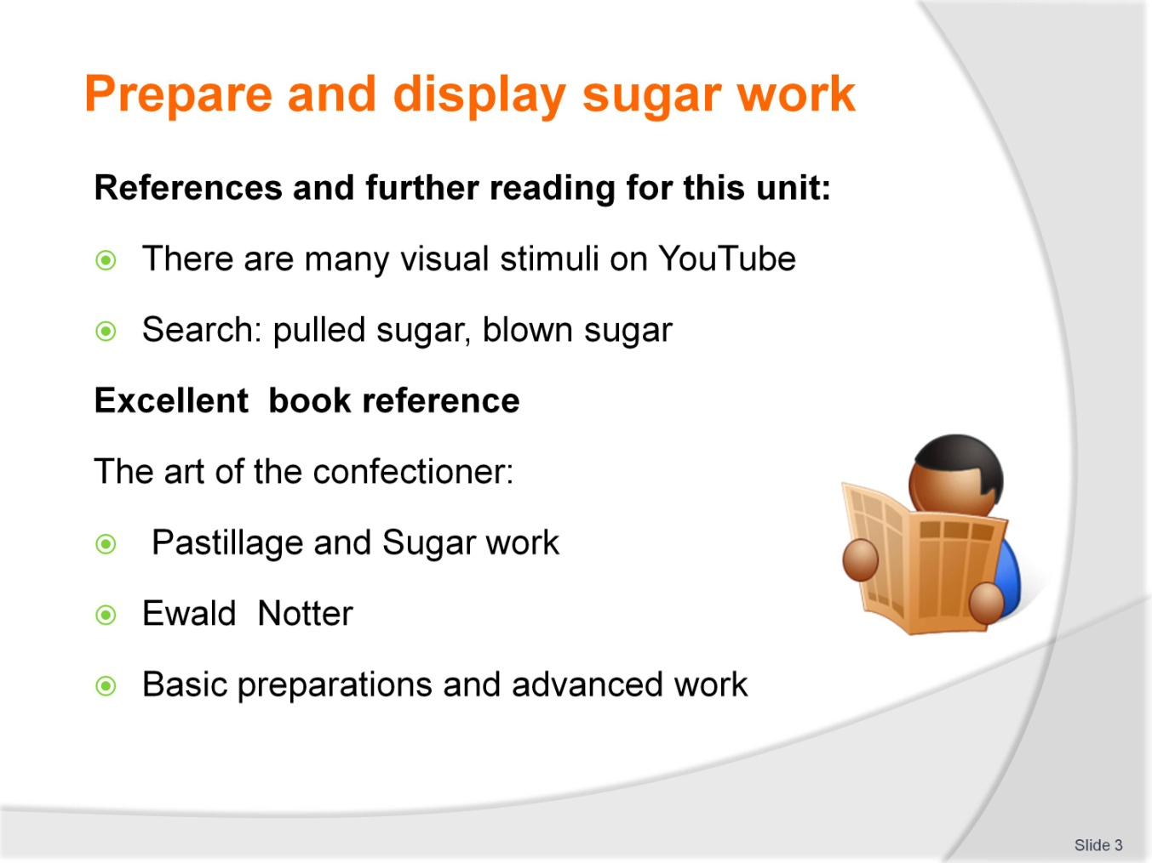
Slide No | Trainer Notes
Trainer to Advise
There are many books and guides in the market place
Difficult to learn this without hands on experience and also an artistic flair is very beneficial
Visual stimuli is available on YouTube.

Slide
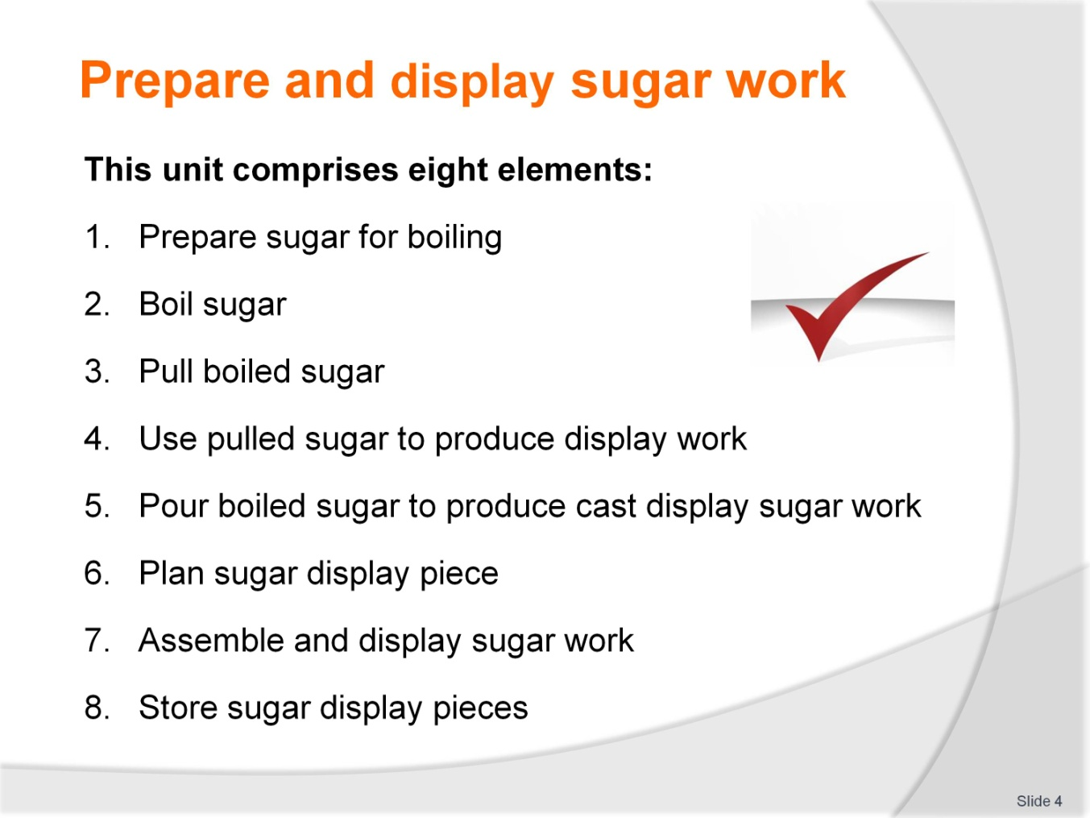
Slide No | Trainer Notes
Trainer to advise
Trainer advises students this Unit comprises eight elements, as listed on the slide explaining:
Each Element comprises a number of Performance Criteria which will be identified throughout the class and explained in detail
Students can obtain more detail from their Trainee Manual
The course presents advice and information but where their workplace requirements differ to what is presented, the workplace practices and standards must be observed.

Slide
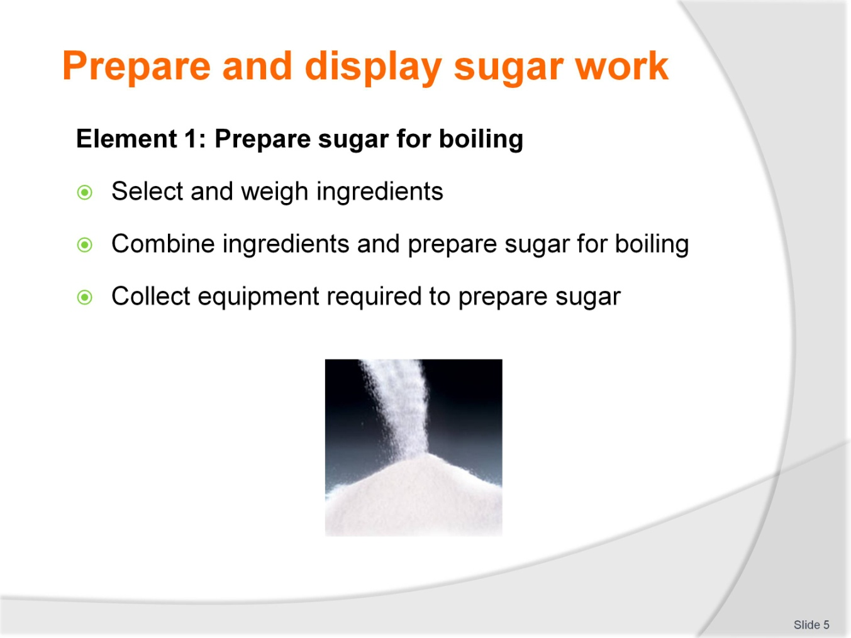
Slide No | Trainer Notes
Trainer to advise
Trainer to relate performance criteria to element 1
Performance criteria is the process by which the students training match the learning element
The element is the skill
To assess competency in the skill; the performance criteria is used to outline activities that can be used to assess competency
The trainer should relate how the performance criteria is related to the element
To be able to Prepare and display sugar work the students must be able to; Pull boiled sugar
The student should be able to do:
- Collect equipment required to pull boiled sugar
- Manipulate boiled sugar
- Store/hold pulled sugar.

Slide
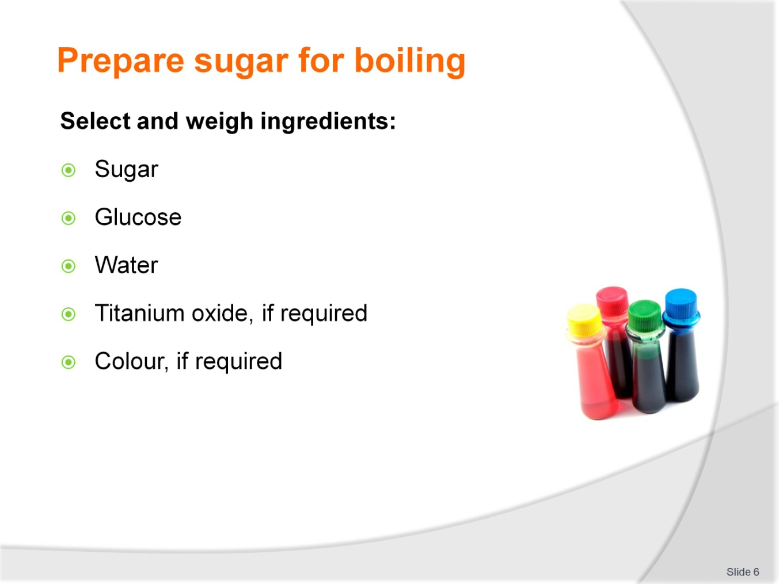
Slide No | Trainer Notes
Trainer to advise
Select and Weigh all ingredients before beginning the process
Ensure that enough of each ingredient is available
Normal table sugar is best for this activity
Students need to find an explanation or definition of how sugar can be purchased in their market place
The term market place is not where you purchase general food items for the home
The market place is the Bakery Patisserie in which they are conducting business:
- A1 or1A sugar – general table sugar
- Caster sugar – best for use in pastry
- Pure icing sugar – very fine grind, can be referred to confectioners sugar
- Soft icing mixture –icing sugar with starch added to stop clumping due to hydroscopic properties of sugar
- Brown sugar – sugar with residual molasses added
These are types of sugar available in the Australian market for the patissier.

Slide
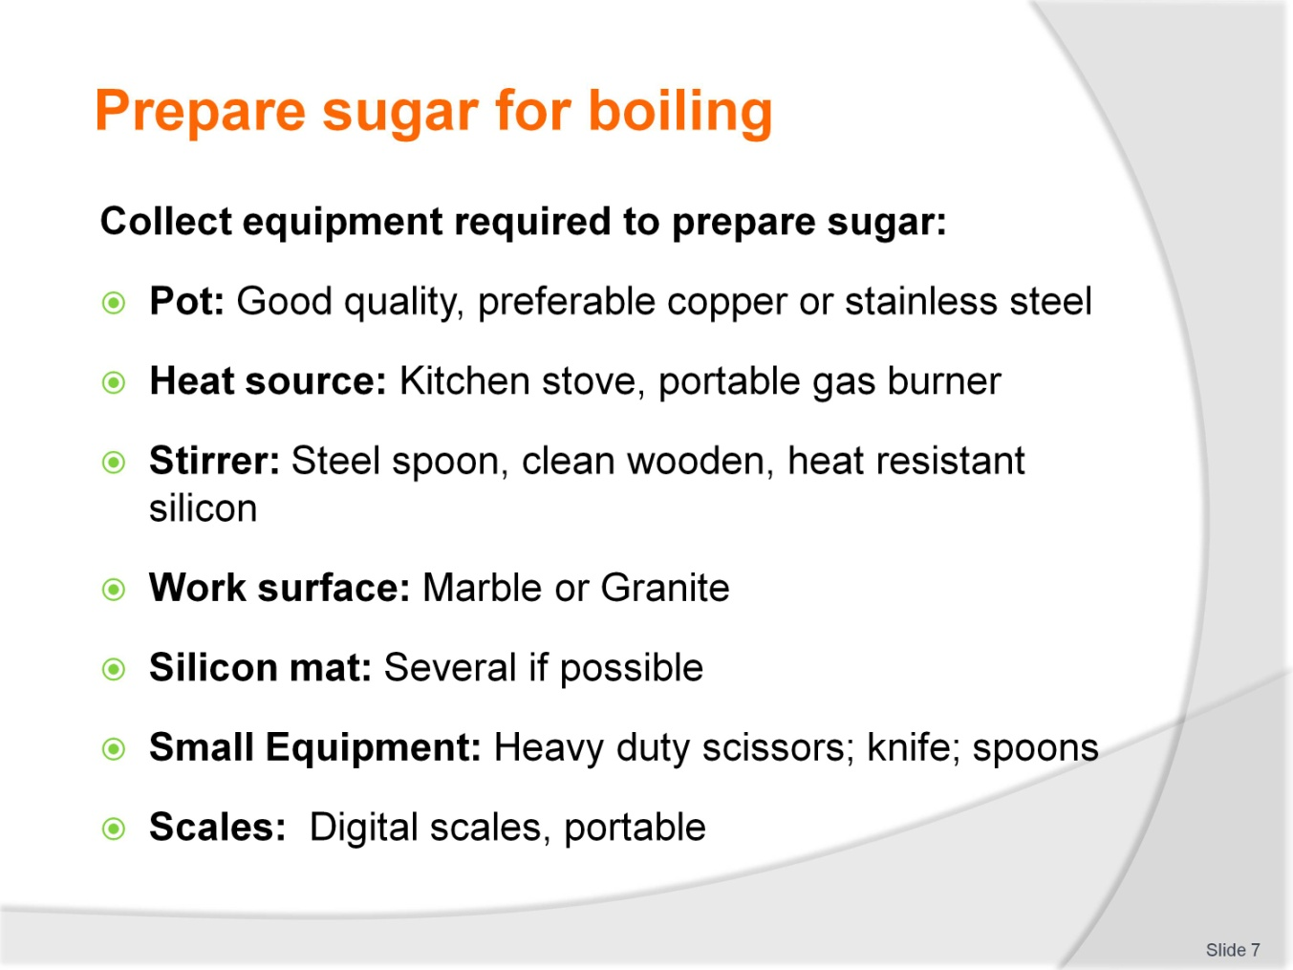
Slide No | Trainer Notes
Trainer to advise
Equipment required for the preparation of sugar will depend on the type being produced
A well set up kitchen will be ideal but people become inventive when lacking the best equipment
Sugar can be boiled and moulded in any area when person becomes familiar with the skills required.

Slide
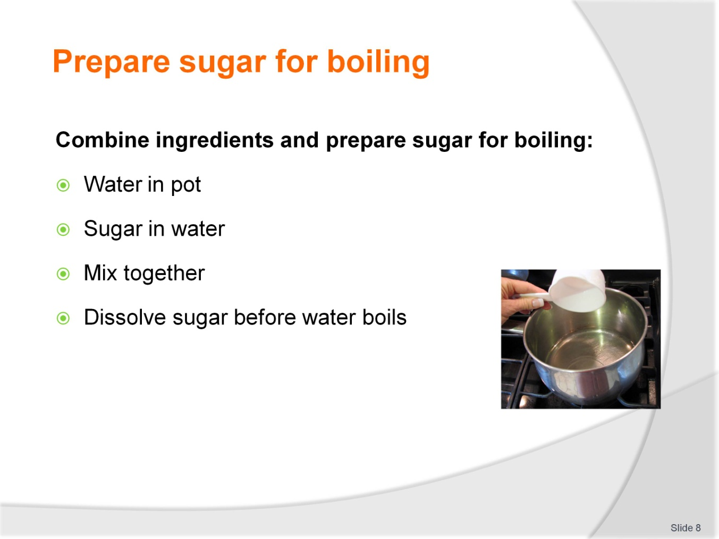
Slide No | Trainer Notes
Trainer to advise
Place the water into a clean pot
Add sugar to the water
This moistens all the sugar and helps it to dissolve
Sugar can re-crystallise when in solution merely due to the fact that a grain of sugar has fallen into the solution
This can happen when sugar is 160 degrees plus. It merely goes hard again and the process needs to start all over again
Keep side of pots clean with pastry brush and cold water
Do not stir after sugar solution has started to boil because the agitation can also cause the sugar to re-crystallise.

Slide
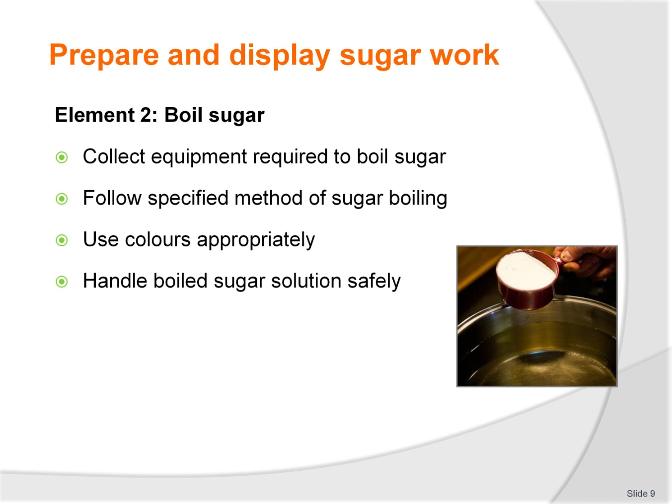
Slide No | Trainer Notes
Trainer to advise
Trainer to relate performance criteria to element 2
Performance criteria is the process by which the students training match the learning element
The element is the skill
To assess competency in the skill; the performance criteria is used to outline activities that can be used to assess competency.
The trainer should relate how the performance criteria is related to the element
To be able to Prepare and display sugar work the students must be able to; Boil sugar
The student should be able to do:
- Collect equipment required to boil sugar
- Follow specified method of sugar boiling
- Use colours appropriately
- Handle boiled sugar solution safely.

Slide
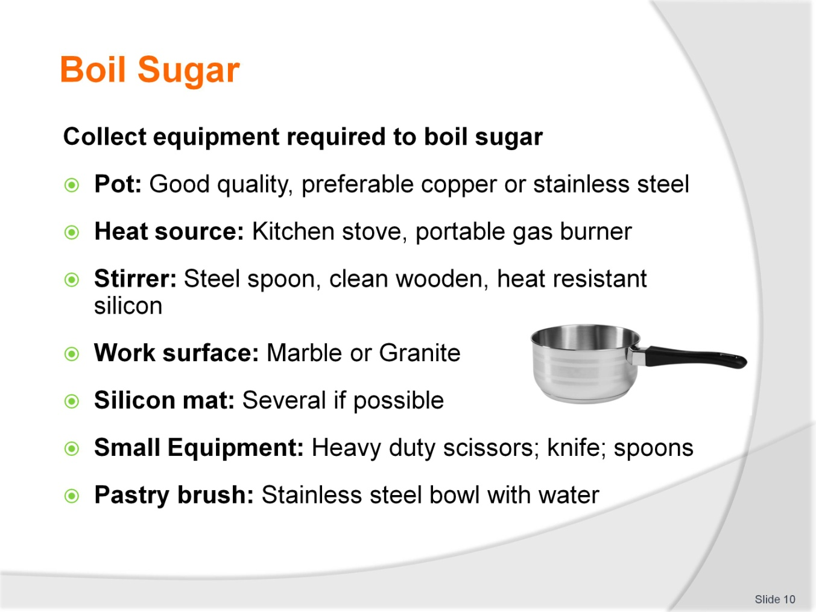
Slide No | Trainer Notes
Trainer to advise
Equipment required for the preparation of sugar will depend on the type being produced
A well set up kitchen will be ideal but people become inventive when lacking the best equipment
Sugar can be boiled and moulded in any area when person becomes familiar with the skills required
For the boiling process to begin all equipment required for the process of moulding should be prepared
Before you begin to cook the sugar the mould must be prepared ready to accept the sugar
When the sugar reaching correct temperature it must be poured immediately
Either into the prepared cast or mould or onto a prepared surface for pulling to produce satin finish.

Slide
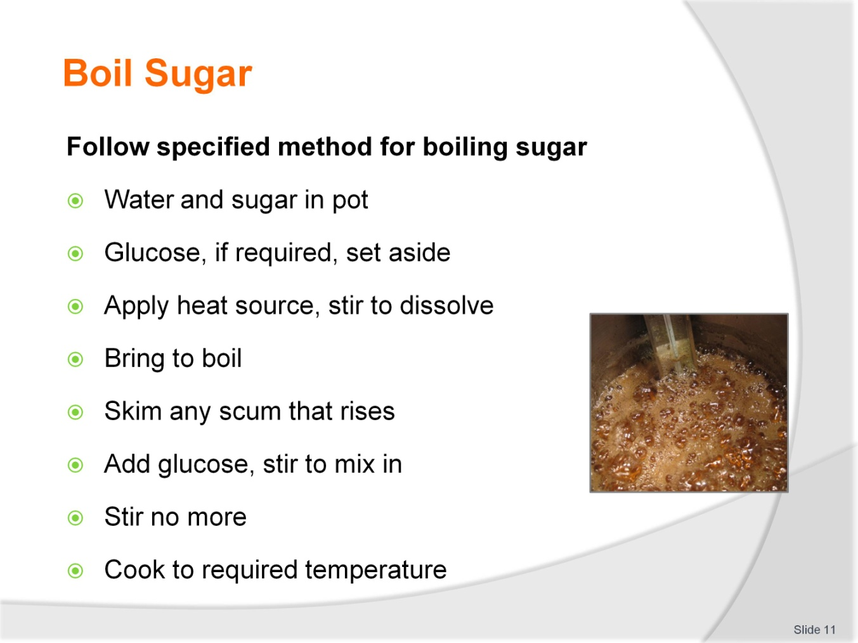
Slide No | Trainer Notes
Trainer to advise
Basic procedure for boiling all sugar solutions
Place on the heat source and stir slowly to dissolve the sugar
Wash sides of pot down with cold water and pastry brush
This is to prevent the sugar solution that sticks to the sides of the pot from dehydrating and forming sugar crystals. If the sugar crystals fall back into the solution there is the possibility that it will act as a seeding agent and this will cause all the sugar to re-crystallise
The glucose can be warmed before going into solution; in microwave or just warmed in another pot; this is recommended in colder environments as when it is added to boiling solution it does not slow down the boiling process to a great extent
When the solution has come to the boil add the glucose
Stir to distribute the glucose through the solution then remove stirrer
Do not stir the solution again; agitation of the solution can cause crystallization
Cook the solution to the required temperature
Add tartaric acid if required at 145 degrees
If colour is to be added then add at approximately 150 degrees
Continue to cook to 160 degrees.

Slide
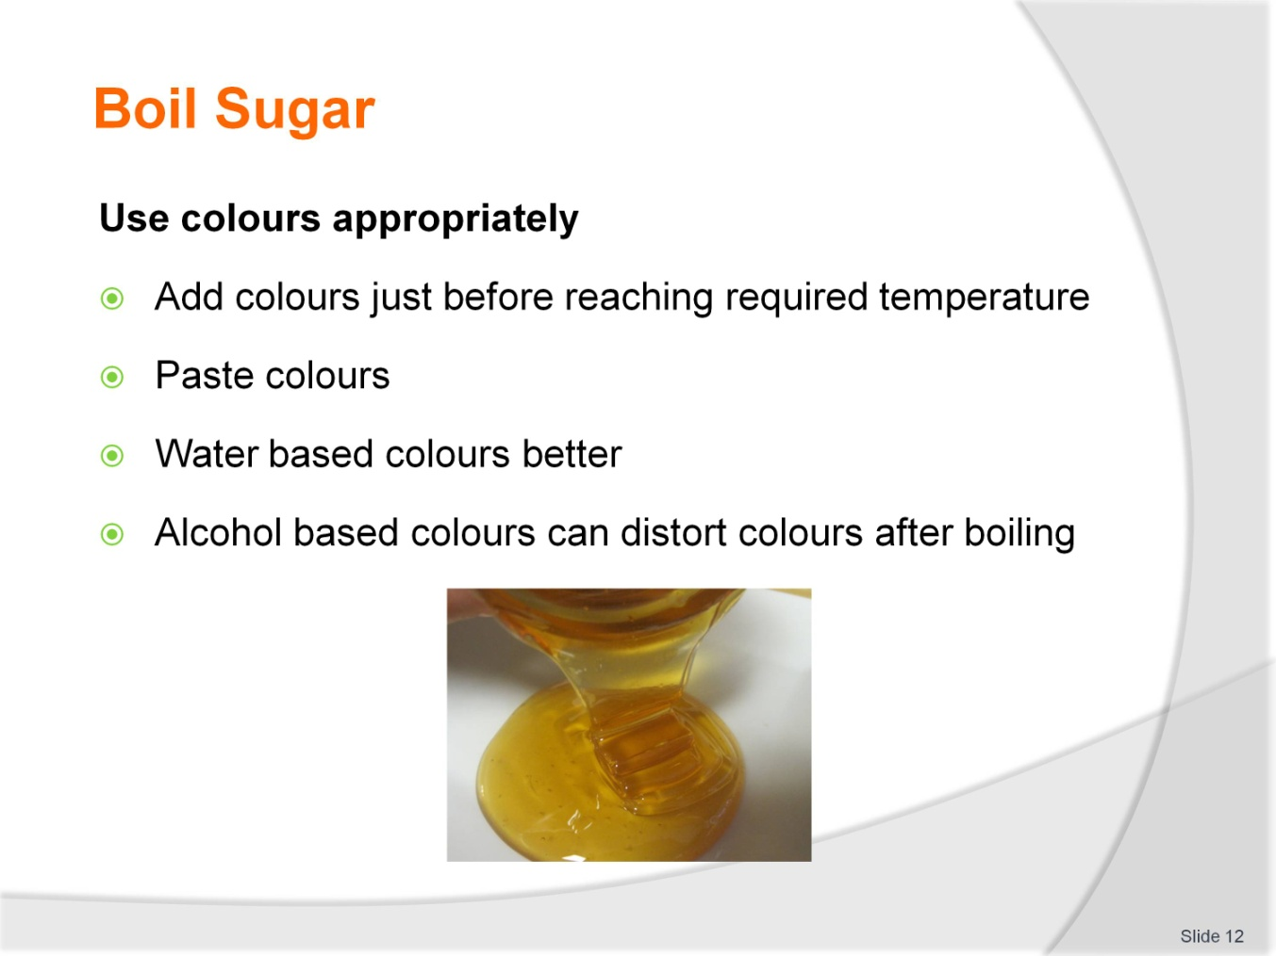
Slide No | Trainer Notes
Trainer to advise
Adding colours to sugar takes practice. It is not the adding of the colour but how the colour looks after it has been added
The brand
Quality of colour
Concentration of the colour
Brightness
HOW MUCH of the colour do you need to add
It all takes practice; keep note as with all recipes and methods; keep notes on the reactions when using a new product for the first time
Water based colours are best added in the last few minutes of the boiling so excess moisture can be evaporated off.

Slide
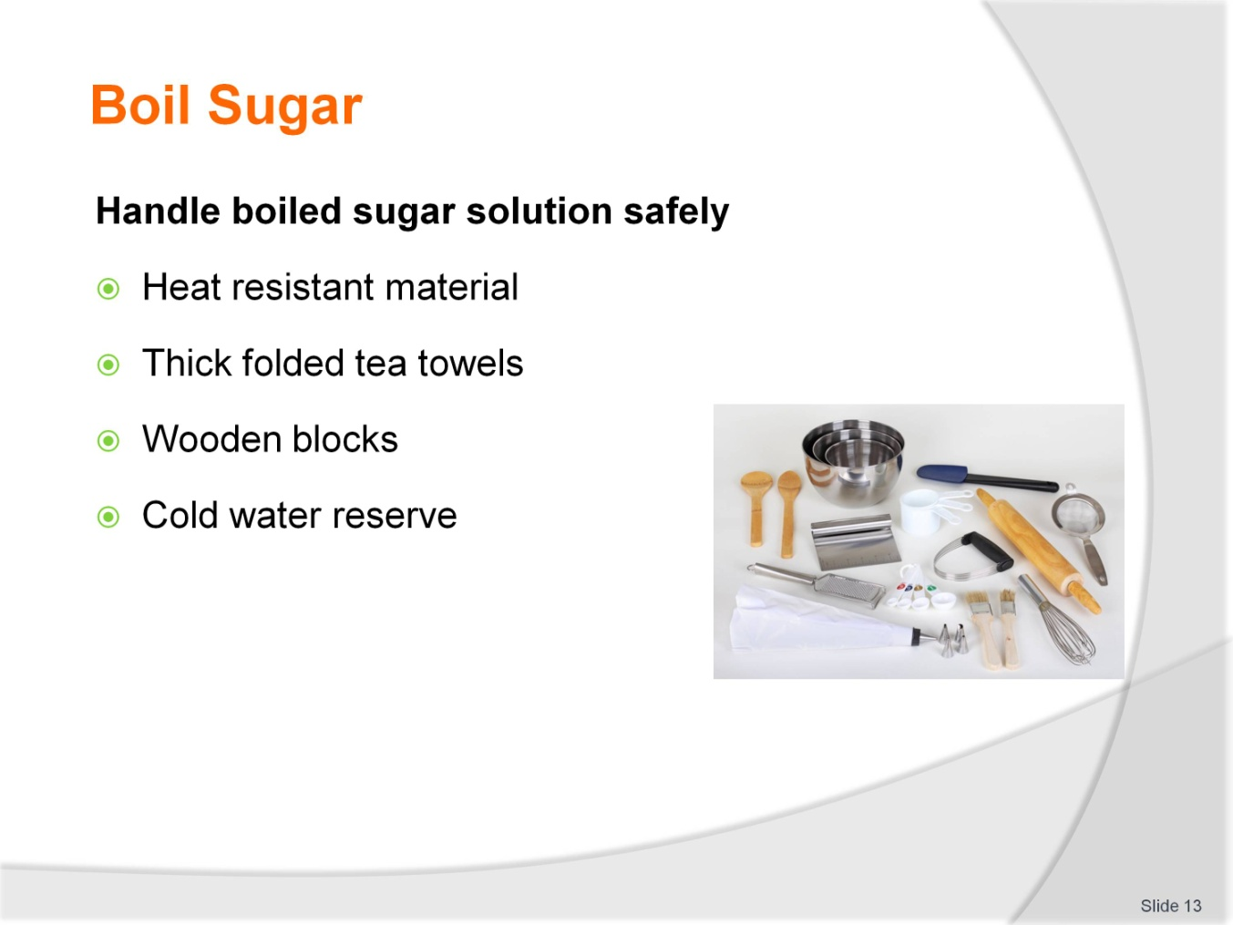
Slide No | Trainer Notes
Trainer to advise
Sugar is boiled to temperatures in excess of 160 degrees:
At this temperature the human skin will just be destroyed within 1 second of contact
RESPECT the sugar
Respect the temperature
THINK
There will be no second chance
Heat resistant material
Thick folded tea towels:
- Thick gloves can be difficult to use and thick cotton gloves are not recommended because if the gloves are wet or even damp and the gloves come into contact with hot metal for any period of time they will heat up and produce STEAM; if the gloves cannot be removed quickly then they become a danger in themselves
- Steam burn are just as bad as dry burns on the human skin
- Folded tea towels between the hot metal and the human skin allows for a faster release of the pot handle
- Care must be taken to still control the molten sugar and not to drop the pot of sugar and cause more damage. Put the pot of molten sugar onto a stable flat surface before releasing grip of hot pot
Wooden blocks:
- Wooden blocks are a good medium to use to reduce heating the workbench surface
Cold water reserve:
- Always have a bowl of cold water nearby to cool any sugar that comes into contact with human skin. It is easy to remove from skin when it has set
- If you try to remove while it is still molten you will just increase the damage.

Slide
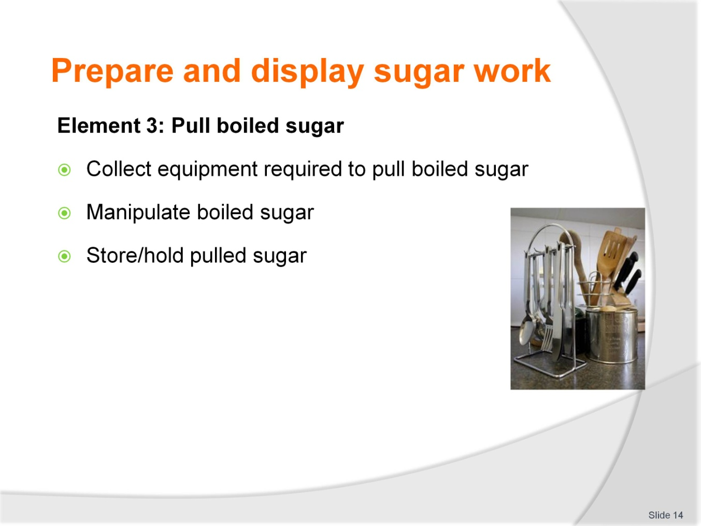
Slide No | Trainer Notes
Trainer to advise
Trainer to relate performance criteria to element 3
Performance criteria is the process by which the students training match the learning element
The element is the skill
To assess competency in the skill; the performance criteria is used to outline activities that can be used to assess competency.
The trainer should relate how the performance criteria is related to the element
To be able to Prepare and display sugar work the students must be able to; Pull boiled sugar
The student should be able to do:
- Collect equipment required to pull boiled sugar
- Manipulate boiled sugar
- Store/hold pulled sugar.

Slide
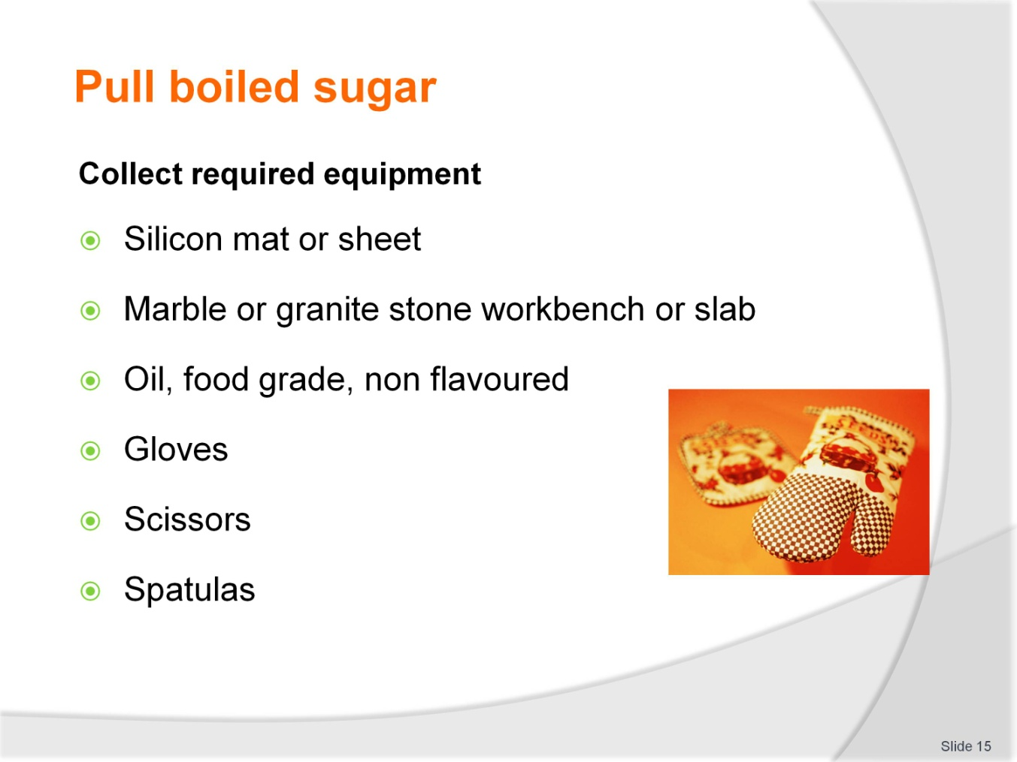
Slide No | Trainer Notes
Trainer to advise
Silicon mat or sheet:
- The boiled sugar will be poured onto this or an oiled marble bench or oiled slab of granite stone
Marble or granite stone workbench or slab:
- Oiled to prevent sugar sticking and will aid in the cooling
Oil, food grade, non flavoured:
- Needs to be applied very sparsely, you do not want the oil entering inside the sugar when folding and pulling
Gloves:
- Always wear latex gloves when pulling. Sometime it is advisable to have thin cotton gloves under latex gloves to insulate
Scissors:
- Are used to cut pulled sugar into portions when ready so it can be stored until required. Easier to reheat
Spatulas:
- Small triangle blade plaster spreaders or cooks spatulas are ideal for turning the sugar back onto itself while it is cooling until it can be handled by hand
- Used to lift the edge and drop back into the centre of the hot solution as it cools.

Slide
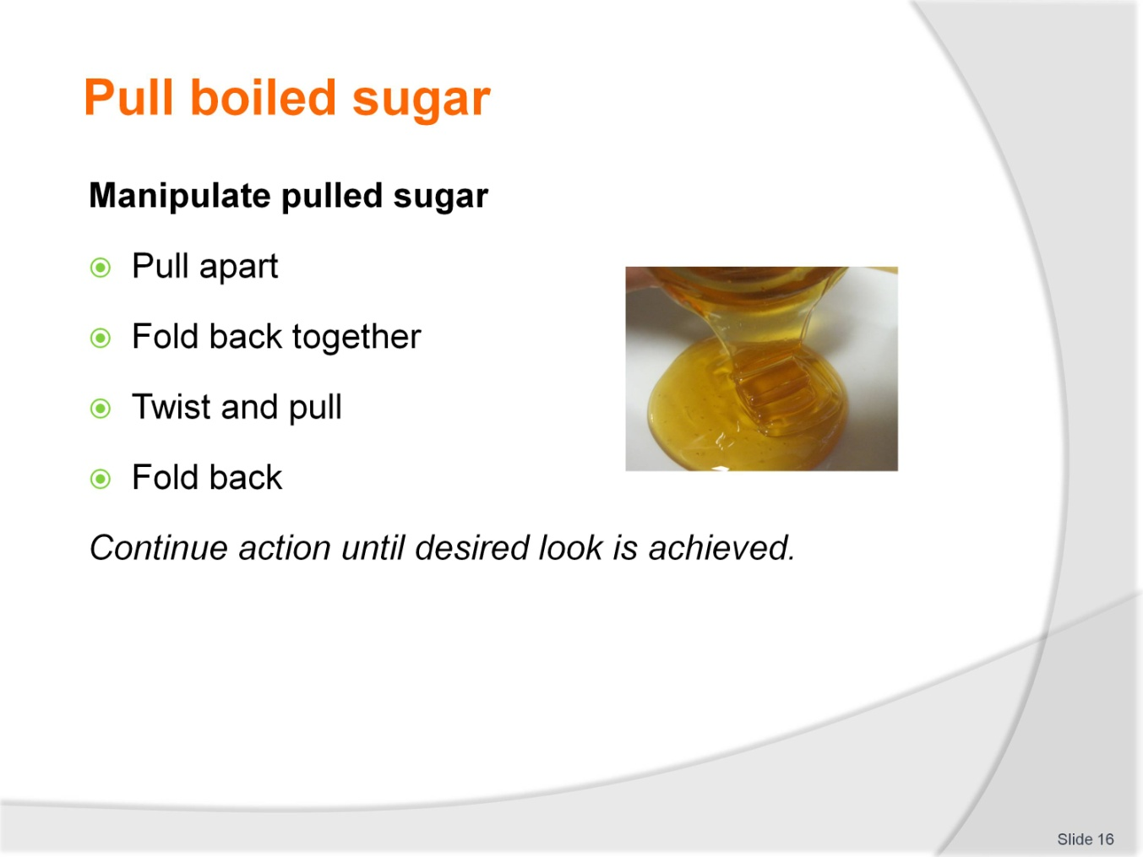
Slide No | Trainer Notes
Trainer to advise
When the sugar has cooled sufficiently to be picked up and handled it can be gripped with two hands and pulled slightly and then fold back together
This process will happen up to 35 times
When folding it can be twisted and folded back together
Why?
This action introduces air into the sugar mass and it takes on a satin or opaque sheen
This action is continued until the desired look is achieved.

Slide
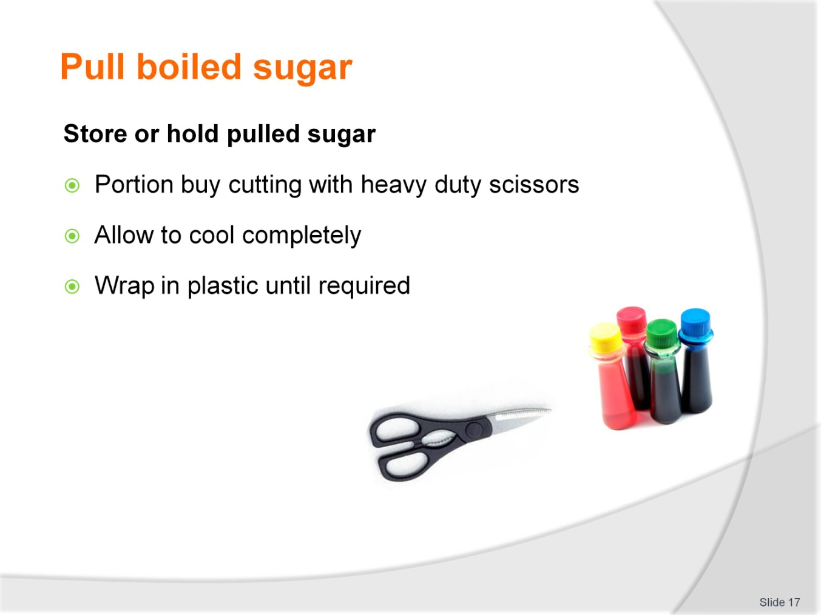
Slide No | Trainer Notes
Trainer to advise
The sugar needs to be portioned while it is still pliable
When portioned it should be left to cool completely
Seal in plastic. Remove all air and store in sealable container
In warmer climates silica gel sachets need to be placed into storage containers
Moisture is the enemy of sugar.

Slide
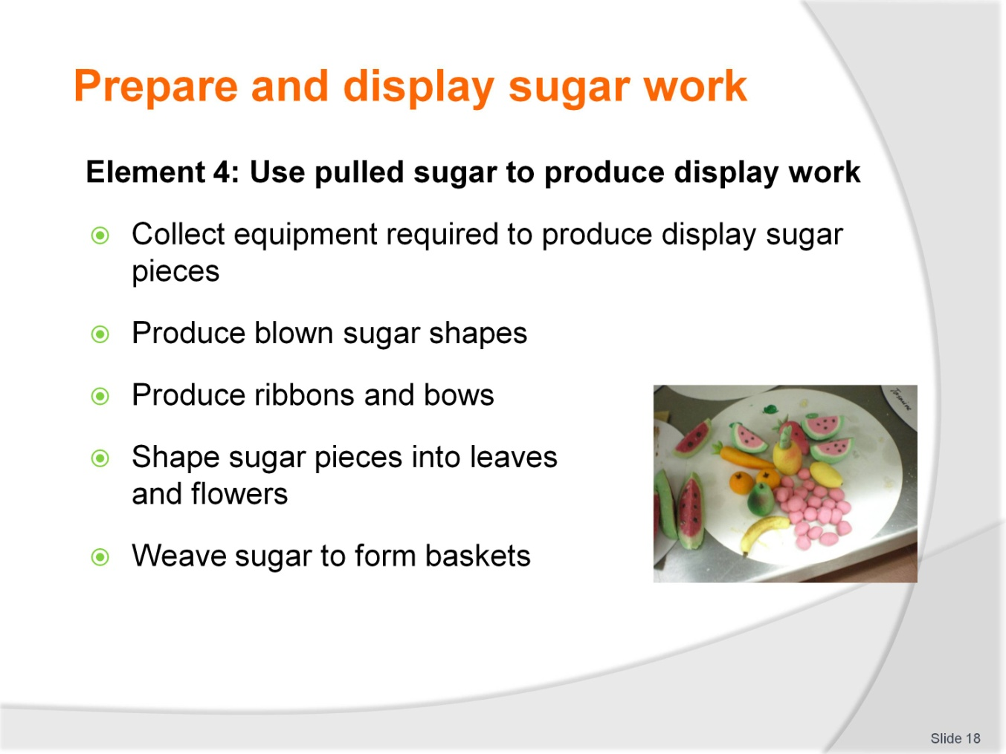
Slide No | Trainer Notes
Trainer to advise
Trainer to relate performance criteria to element 4
Performance criteria is the process by which the students training match the learning element
The element is the skill
To assess competency in the skill; the performance criteria is used to outline activities that can be used to assess competency
The trainer should relate how the performance criteria is related to the element
To be able to Prepare and display sugar work the students must be able to; Use pulled sugar to produce display work
The student should be able to:
- Collect equipment required to produce display sugar pieces
- Produce blown sugar shapes
- Produce ribbons and bows
- Shape sugar pieces into leaves and flowers
- Weave sugar to form baskets.

Slide
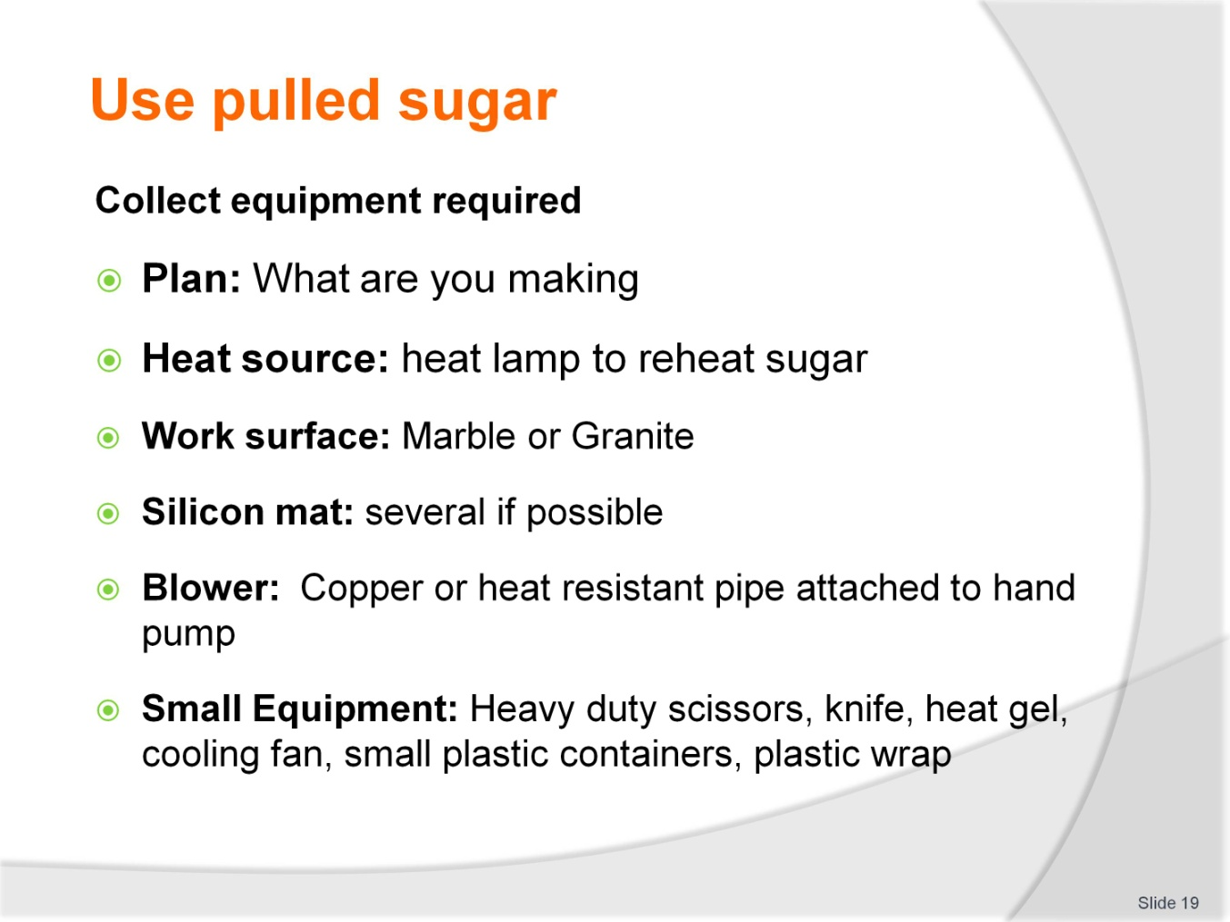
Slide No | Trainer Notes
Trainer to advise
Plan: What are you making
Heat source: Heat lamp to reheat sugar:
- The sugar portion will be placed onto a silicon mat under the heat lamp
- The heat lamp slowly warms the sugar
- Sugar needs to be regularly turned so the sugar cane heat evenly
Blower: Copper or heat resistant reed attached to hand pump:
- Sugar is attached to end and air is introduce to inside of piece of sugar and while sugar is pliable different shapes are formed
- Then cooled to hold shape produced
Work surface: Marble or Granite:
- Good surface to work with
Silicon mat: Several if possible
Small Equipment: Heavy duty scissors; knife:
- As the sugar is formed pieces may need to be trimmed
Small plastic containers:
- Can be handy to hold small pieces after they have been formed
- Line with plastic wrap scrunched up loosely to give support to still warm pieces without deforming them on flat surface
heat gel:
- Burns a single flame that can be used to melt sections without warming the whole model; for binding sugar pieces together
Plastic wrap:
- To line containers to stop pieces banging into each other
Cooling fan, Hair dryer:
- Some have a hot and cold fan; for fast temperature changes to sugar.

Slide
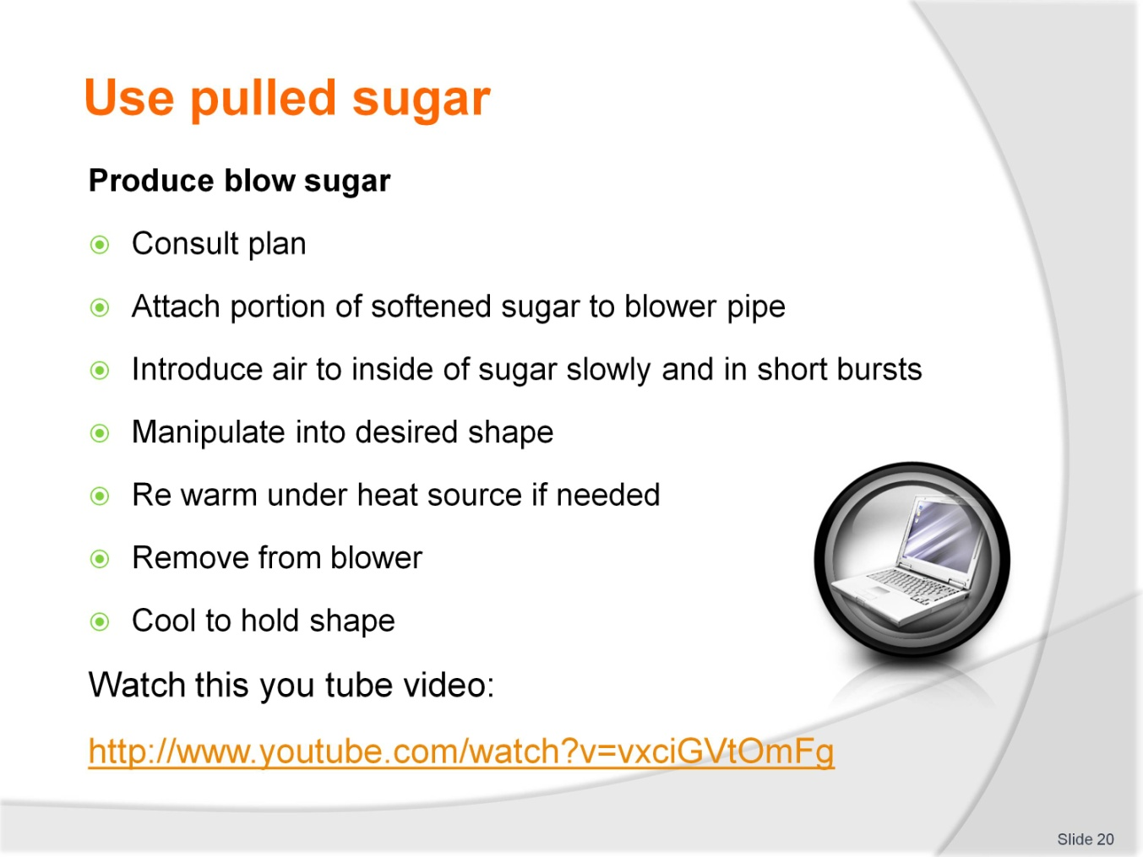
Slide No | Trainer Notes
Trainer to advise
YouTube Chef Robert Lombardy: Inland Northwest Culinary; Spokane; Washington State; USA:
- http://www.youtube.com/watch?v=vxciGVtOmFg
Consult plan
What are you going to produce/ Do you have a drawing to compare your model with?
Attach portion of softened sugar to blower pipe
Take a portion of softened sugar and totally enclose the end of a pipe. When totally sealed:
- Introduce air to inside of sugar slowly and in short bursts
- Manipulate into desired shape
- Re warm under heat source if needed
- Remove from pipe by cutting while retaining shape
- Cool to hold shape.

Slide
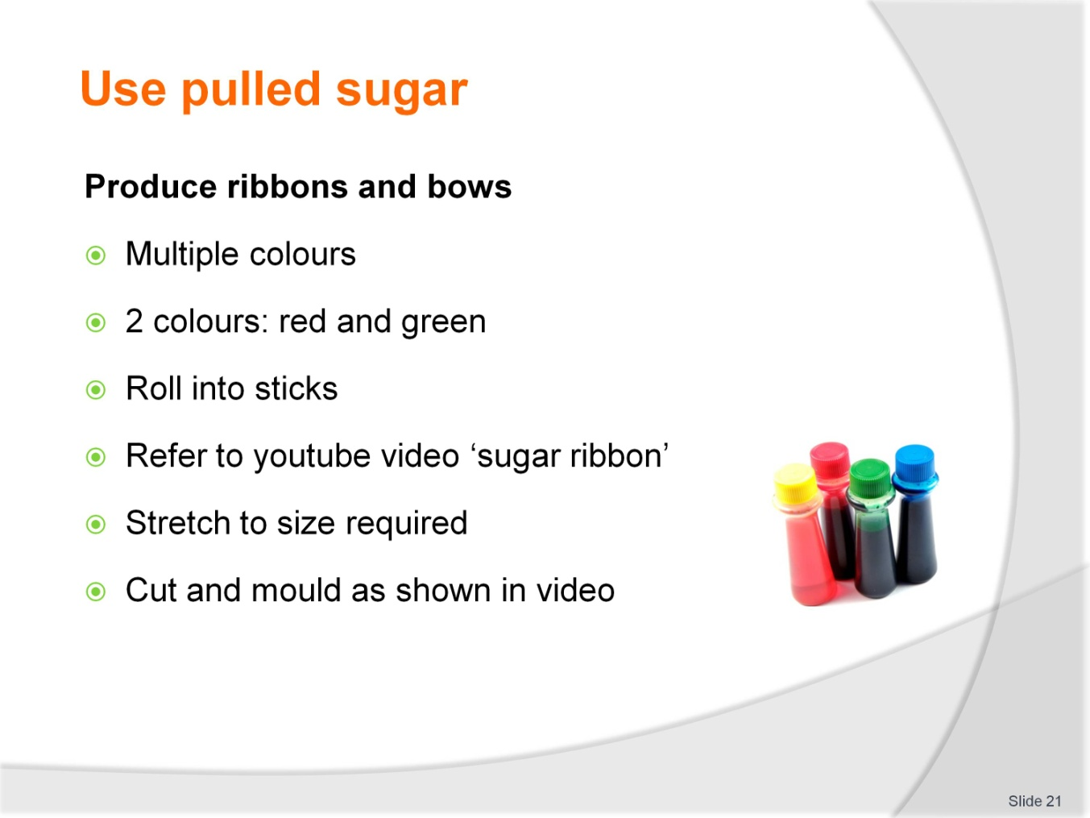
Slide No | Trainer Notes
Trainer to advise
Start with just two colours
Warm pieces of sugar size of finger
Attach to each other
Manipulate long, stretch, trying to keep same thickness
Stretch to final thickness
Cut to length
Warm and shape
Cool to shape.

Slide
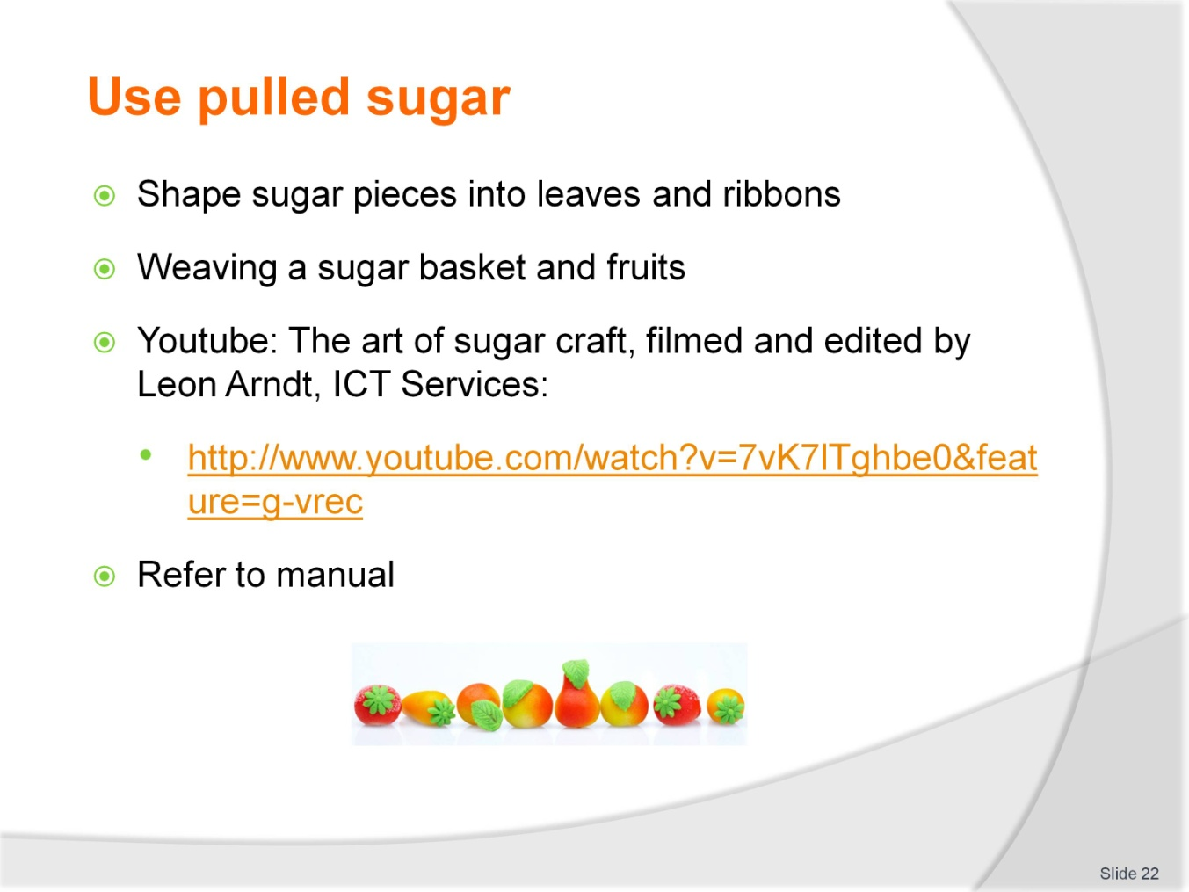
Slide No | Trainer Notes
Trainer to advise
Refer to manual or obtain a video from you tube source for visual display
Weaving a sugar basket and fruits.
You tube
The art of sugar craft; filmed and edited by Leon Arndt, ICT Services:
- http://www.youtube.com/watch?v=7vK7lTghbe0&feature=g-vrec.

Slide
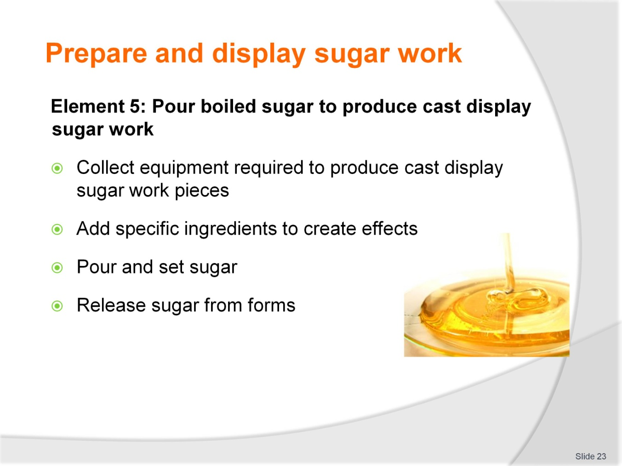
Slide No | Trainer Notes
Trainer to advise
Trainer to relate performance criteria to element 5
Performance criteria is the process by which the students training match the learning element
The element is the skill
To assess competency in the skill; the performance criteria is used to outline activities that can be used to assess competency.
The trainer should relate how the performance criteria is related to the element
To be able to Prepare and display sugar work the students must be able to; pour boiled sugar to produce cast display sugar work
The student should be able to:
- Collect equipment required to produce cast display sugar work pieces
- Add specific ingredients to create effects
- Pour and set sugar
- Release sugar from forms.

Slide
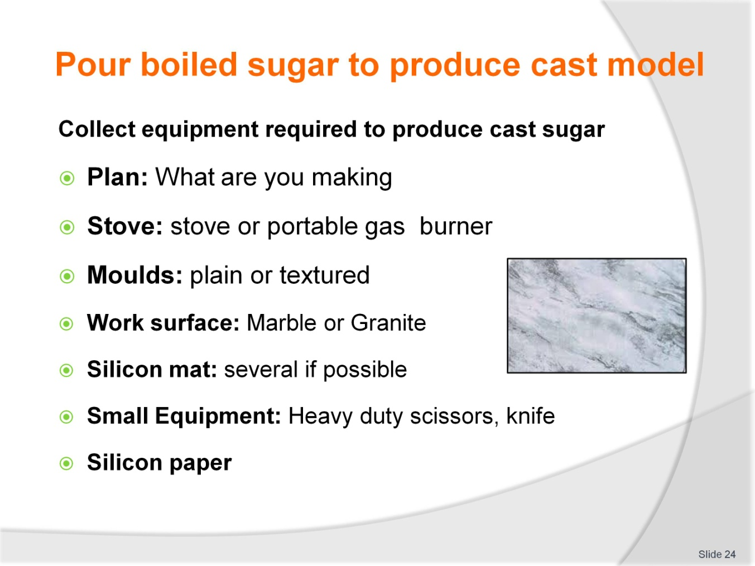
Slide No | Trainer Notes
Trainer to advise
Working from a plan the model must be broken down into sections:
- Cast models have several sections that may sit at different level
- Cast models may lay flat
- May stand up; several pieces set at different places on the base give appearance of Depth
Moulds of the shapes that are going to be moulded
Stove and pot
Small equipment: should always be on hand.

Slide
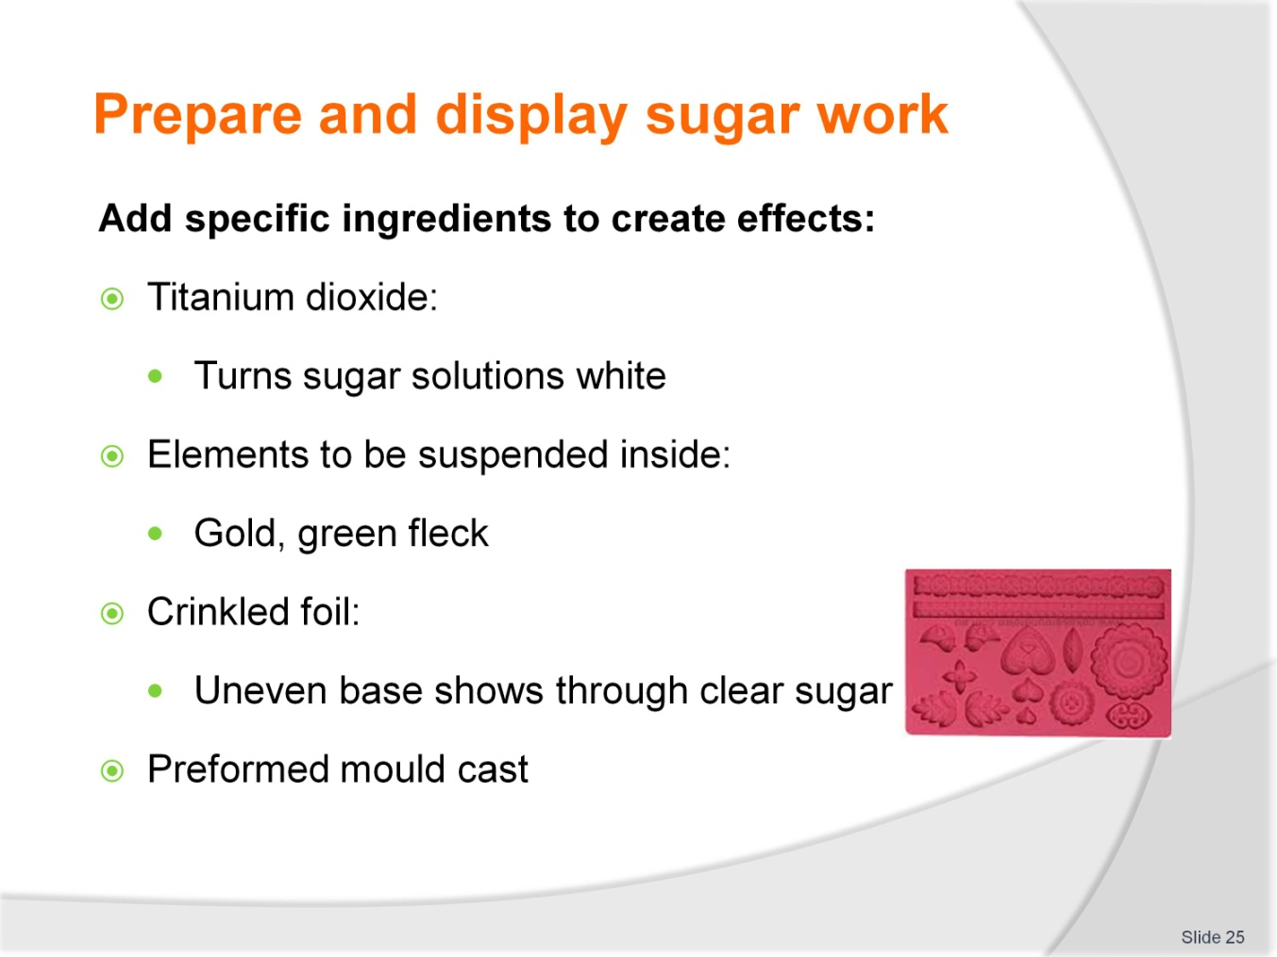
Slide No | Trainer Notes
Trainer to advise
Titanium dioxide:
- Is a natural substance that can be used to give boiled sugar a white colour; helps with showing opaque colours
Elements to be suspended inside:
- Silver sparkle or small filings can be added for sparkle in clear
Crinkled foil:
- Crinkling the foil will show imperfection in foil surface and this will show through a clear sugar cast
Preformed mould cast:
- Silicon moulds can be preformed to shapes of leaves and these do not have to be added as when hand moulding
- See Chicago School of mould making website.

Slide
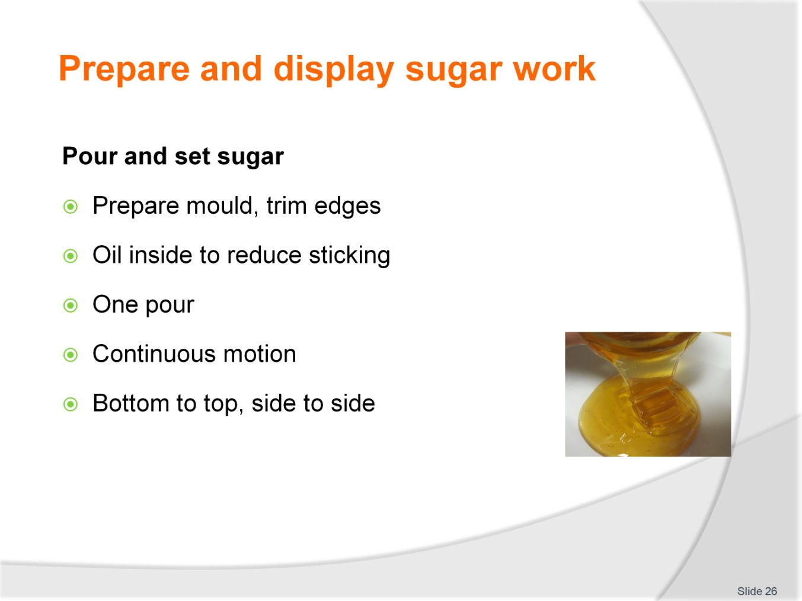
Slide No | Trainer Notes
Trainer to advise
Before pouring ensure that the mould is ready
It is sitting correctly
Edges are sealed
Mould edges are not going to move when sugar is poured
When pouring into cast pour slowly for an even flow
Move from one end or side of mould to the other
This will take practice
If you pour and move too quickly on large moulds and then come back to ‘Top up’ the amount of sugar it may show a wave in the sugar
If waves in cast do not matter then all will be ok
Allow sugar to set
If pieces are small they may be able to be slid into base of baking tray and set aside to cool if tray base is flat and will not distort model.

Slide
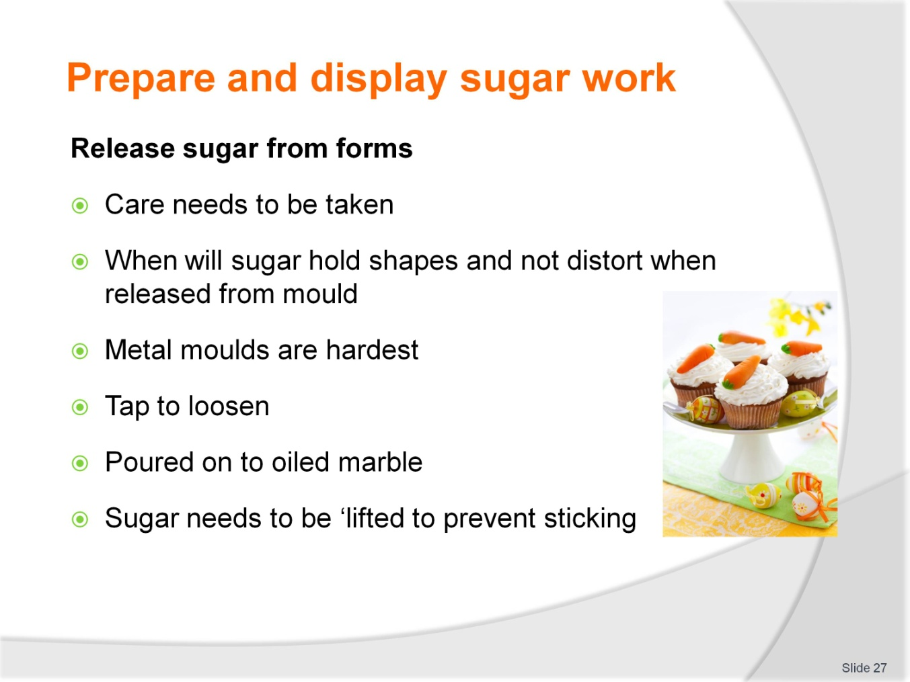
Slide No | Trainer Notes
Trainer to advise
You have boiled the sugar and poured into mould
All can be for nothing because it has failed to come out of the mould
Firm moulds like steel cake rings can be a problem of the sugar sets and it may crack if it is too cold
You cannot have the sugar ‘flex’ or bend when cold. It does not do this, it cracks
So remove from mould as soon as possible; it just needs to hold shape
Sometimes a light tap will release
Warm the edges of the mould with blow torch
If poured directly onto oiled marble bench it will need to be lifted slightly to allow air under to prevent the sugar sticking when cooling

Slide
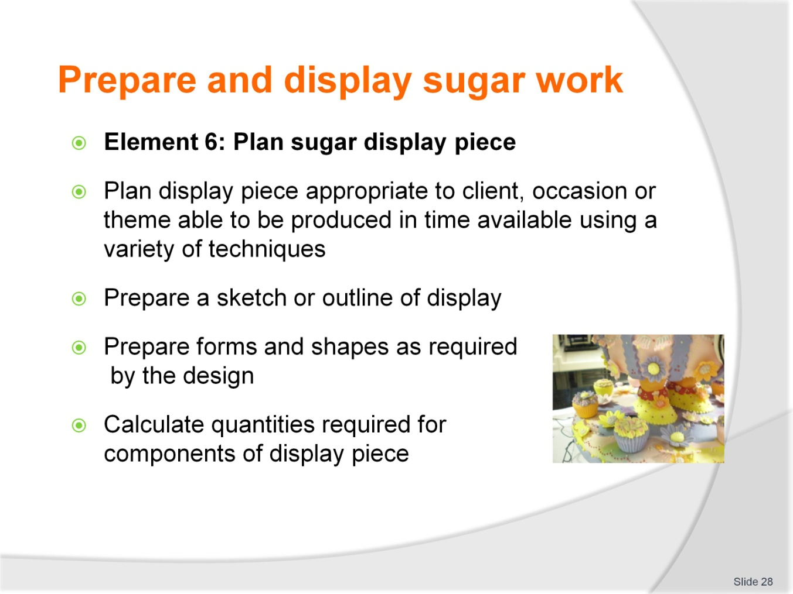
Slide No | Trainer Notes
Trainer to advise
Trainer to relate performance criteria to element 6
Performance criteria is the process by which the students training match the learning element
The element is the skill
To assess competency in the skill; the performance criteria is used to outline activities that can be used to assess competency
The trainer should relate how the performance criteria is related to the element
To be able to Prepare and display sugar work the students must be able to; Plan sugar display piece
The student should be able to:
- Plan display piece appropriate to client, occasion or theme able to be produced in time available using a variety of techniques
- Prepare a sketch or outline of display
- Prepare forms and shapes as required by the design
- Calculate quantities required for components of display piece.

Slide
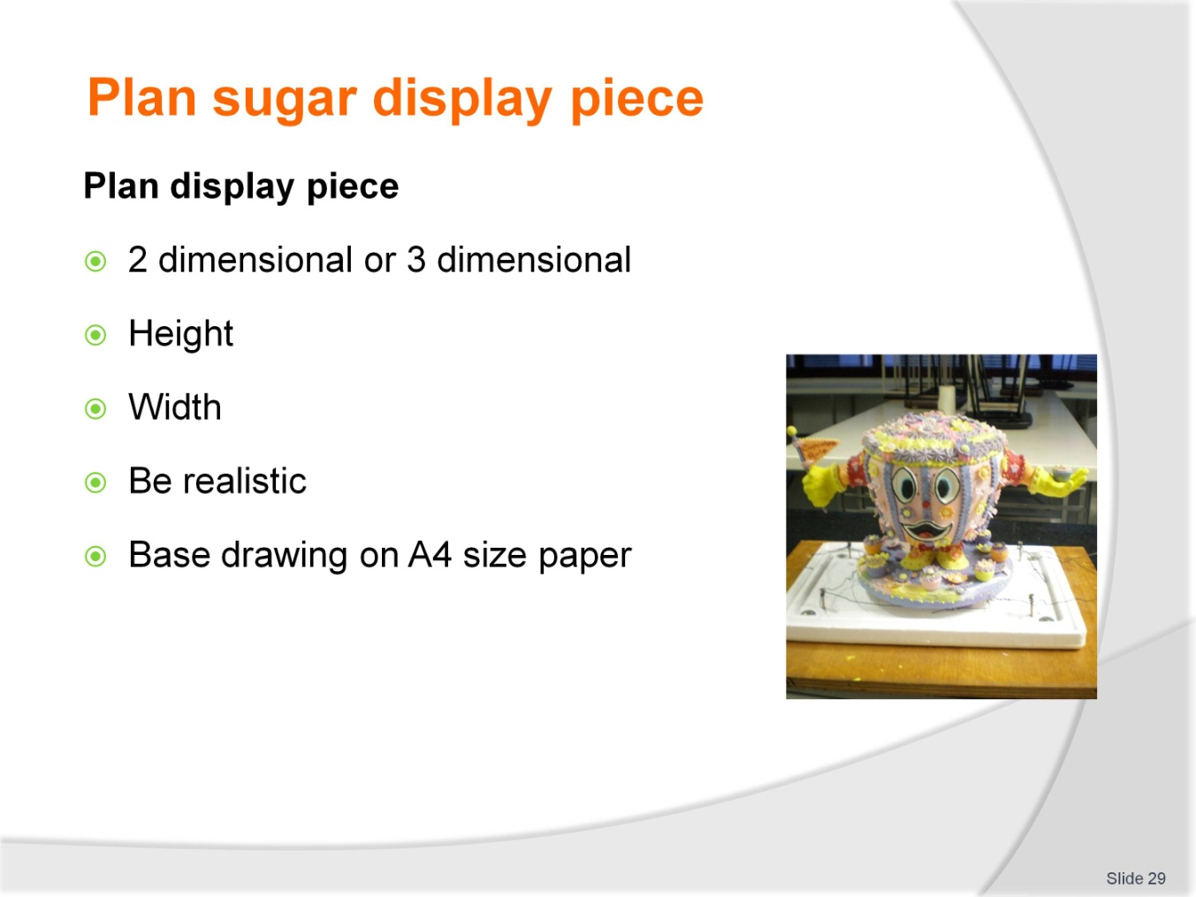
Slide No | Trainer Notes
Trainer to advise
When designing a piece to begin keep it basic; be realistic
Use A4 size paper as your base for all drawings
All stencils must be able to fit inside the parameters of this size, if not smaller.

Slide
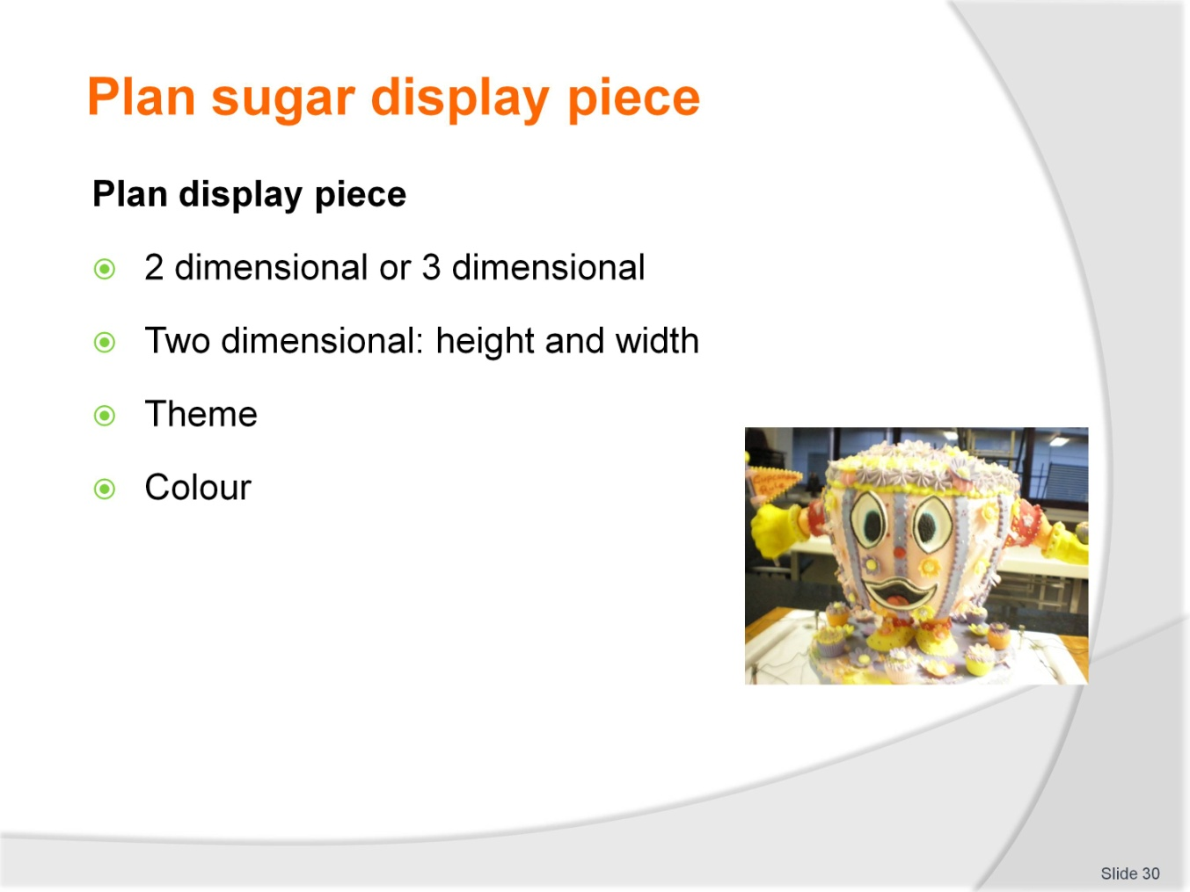
Slide No | Trainer Notes
Trainer to advise
Plan before you start
In beginning it is best to copy another work.
See how others have planned and developed their them
To begin just do one colour, then two, develop technique.

Slide
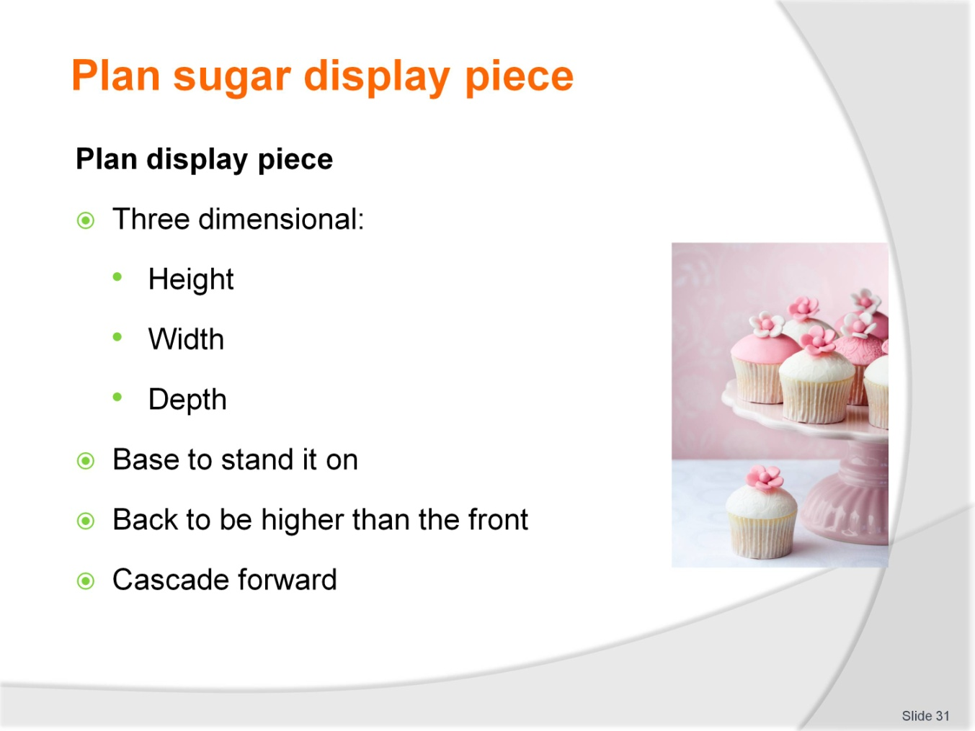
Slide No | Trainer Notes
Trainer to advise
When planning your piece look for it to fall forward toward the front
Do not have something sitting at the back that cannot be seen, unless you have it on a rotating base.

Slide
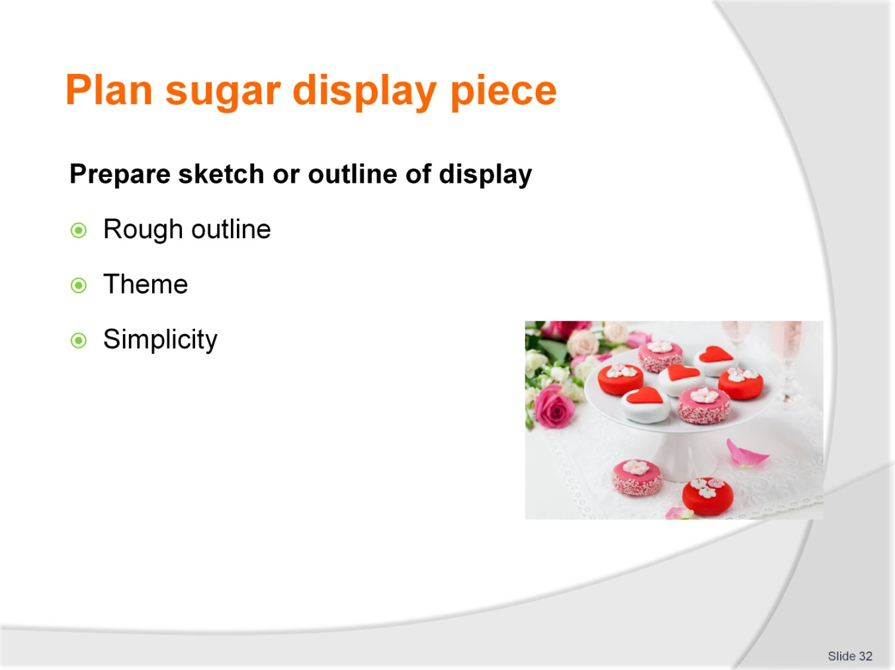
Slide No | Trainer Notes
Trainer to advise
Keep drawing simple
Look to set up curves so they run evenly
Remember to have base flat so it can sit
Keep it simple in beginning
Squares
Ovals
Circles
Geometric shapes of different sizes.

Slide
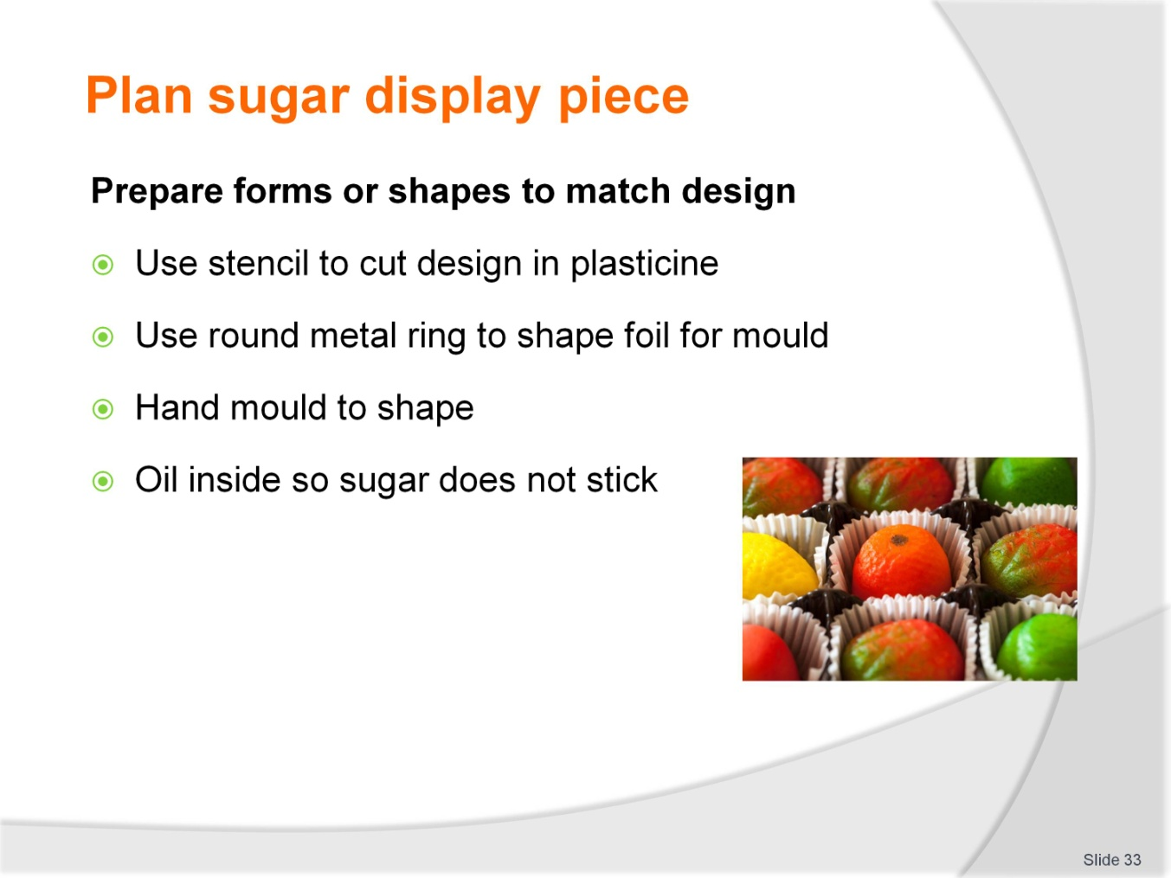
Slide No | Trainer Notes
Trainer to advise
Stencil: a cardboard shape of design laid over the plasticine to cut into plasticine for desired shape
This is a onetime mould; stencil can be used many times
Keep plasticine wrapped to prevent drying
Some practitioners lay thin foil inside plasticine to prevent sticking, some apply oil to edge
Shape some foil using a metal cake ring; this comes in handy when more than one piece is required
Smaller pastry cutters can also be used for moulding
As long as they are secured and will withstand the heat of the molten solution.

Slide
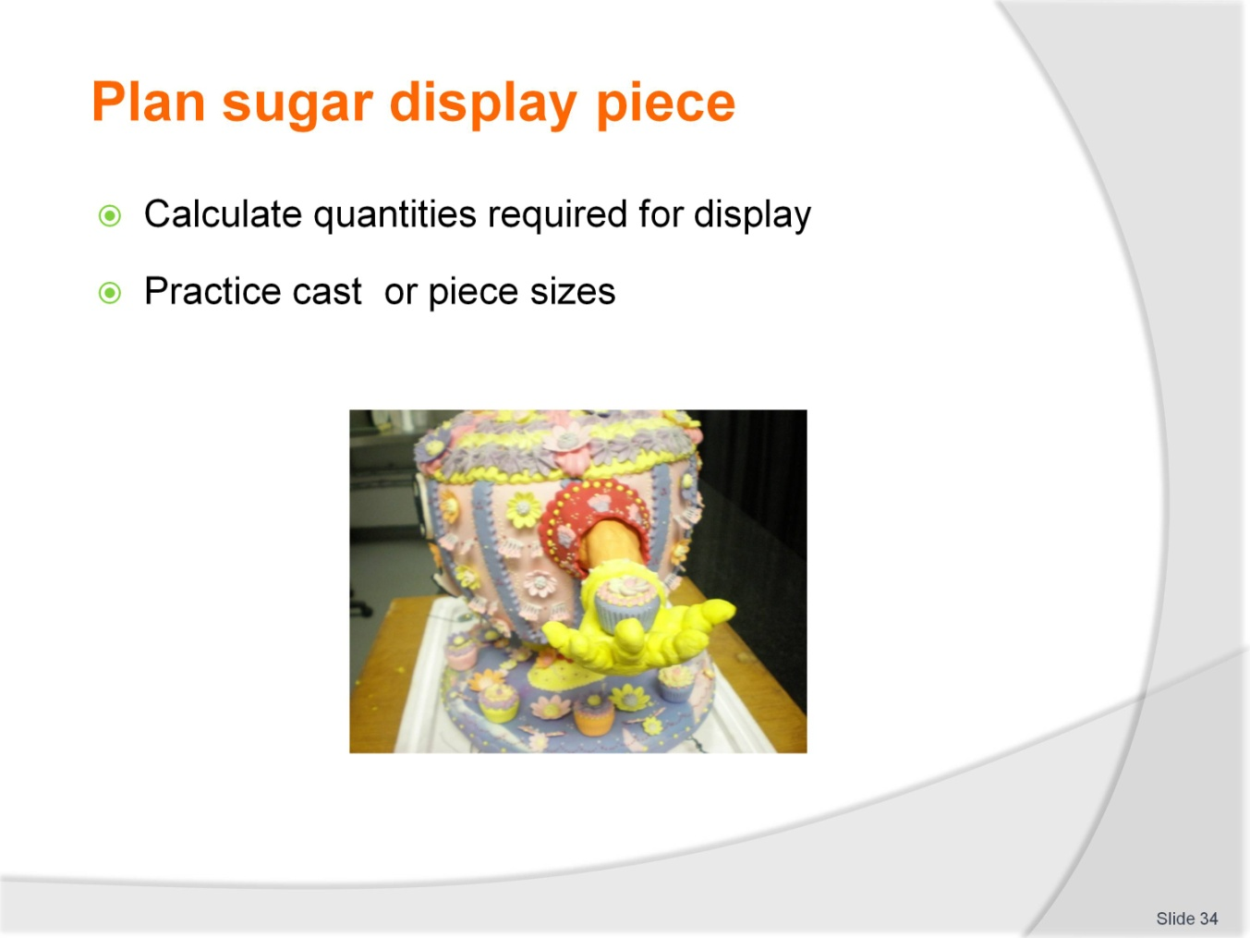
Slide No | Trainer Notes
Trainer to advise
Depends on the size that is being made
Up to 50% more than the actual finished piece.

Slide
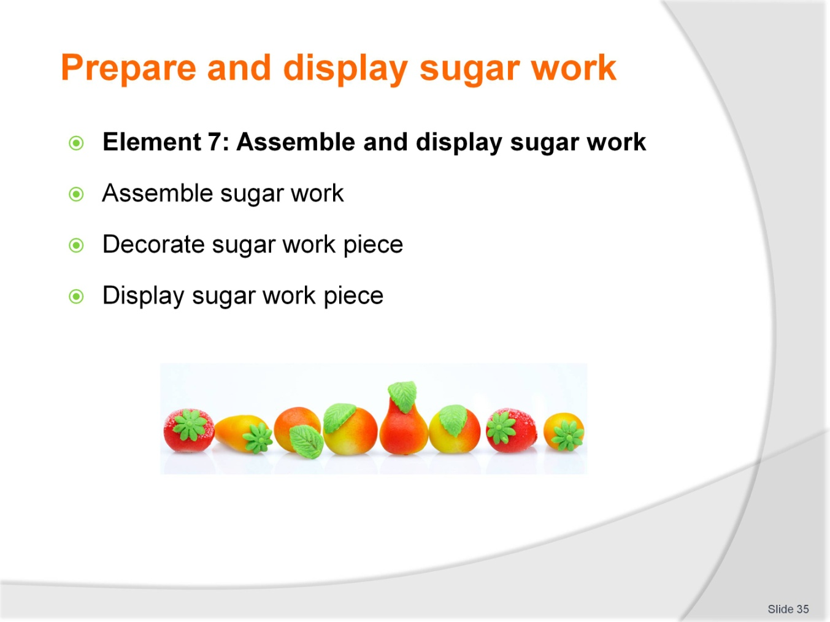
Slide No | Trainer Notes
Trainer to advise
Trainer to relate performance criteria to element 7
Performance criteria is the process by which the students training match the learning element
The element is the skill
To assess competency in the skill; the performance criteria is used to outline activities that can be used to assess competency
The trainer should relate how the performance criteria is related to the element
To be able to Prepare and display sugar work the students must be able to; Assembly and display sugar work
The student should be able to do:
- Plan display piece appropriate to client, occasion or theme able to be produced in time available using a variety of techniques
- Prepare a sketch or outline of display
- Prepare forms and shapes as required by the design
- Calculate quantities required for components of display piece.

Slide
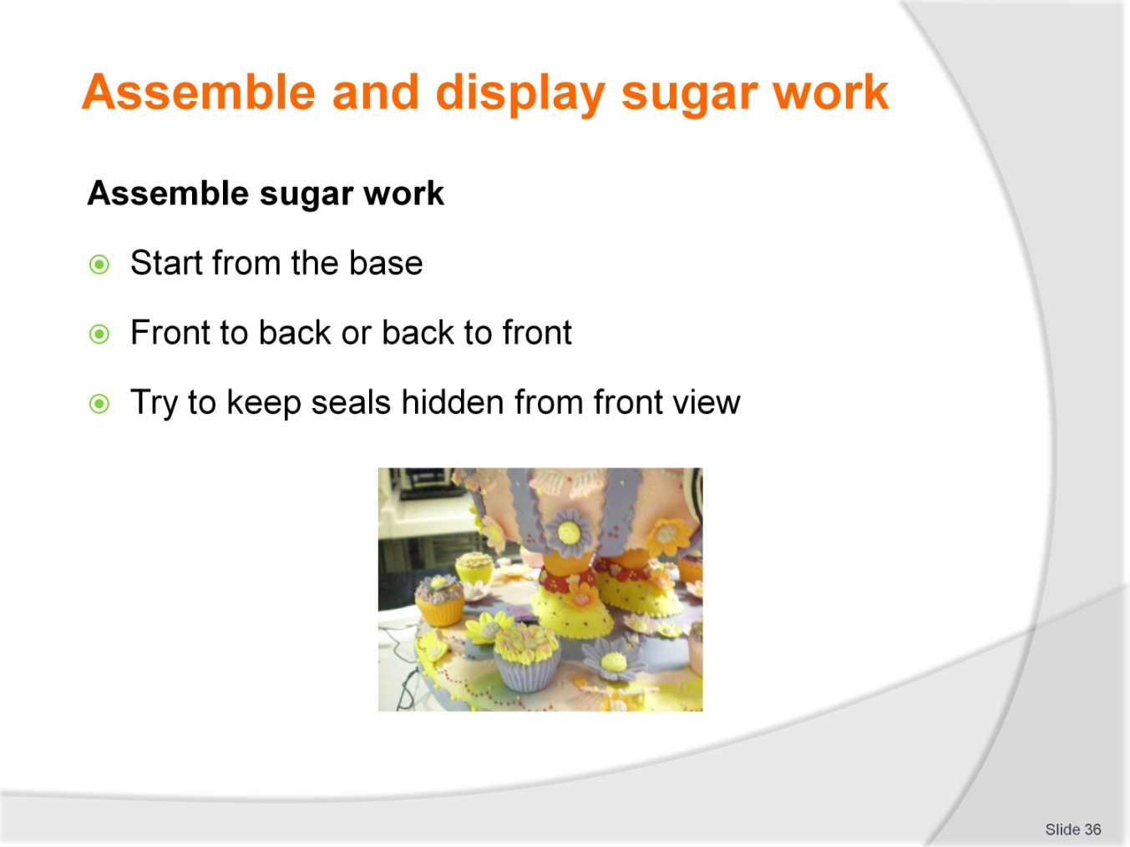
Slide No | Trainer Notes
Trainer to advise
Starting with a clean workspace have all pieces lined up in assembly line
Check all equipment is available
Heat edges of pieces to be joined with spirit lamp or blow torch
REMEMBER: you only need to heat to join, do not melt and deform the shape
Have a fan to assist with cooling
In warmer climates cooling of sugar will be slower.

Slide
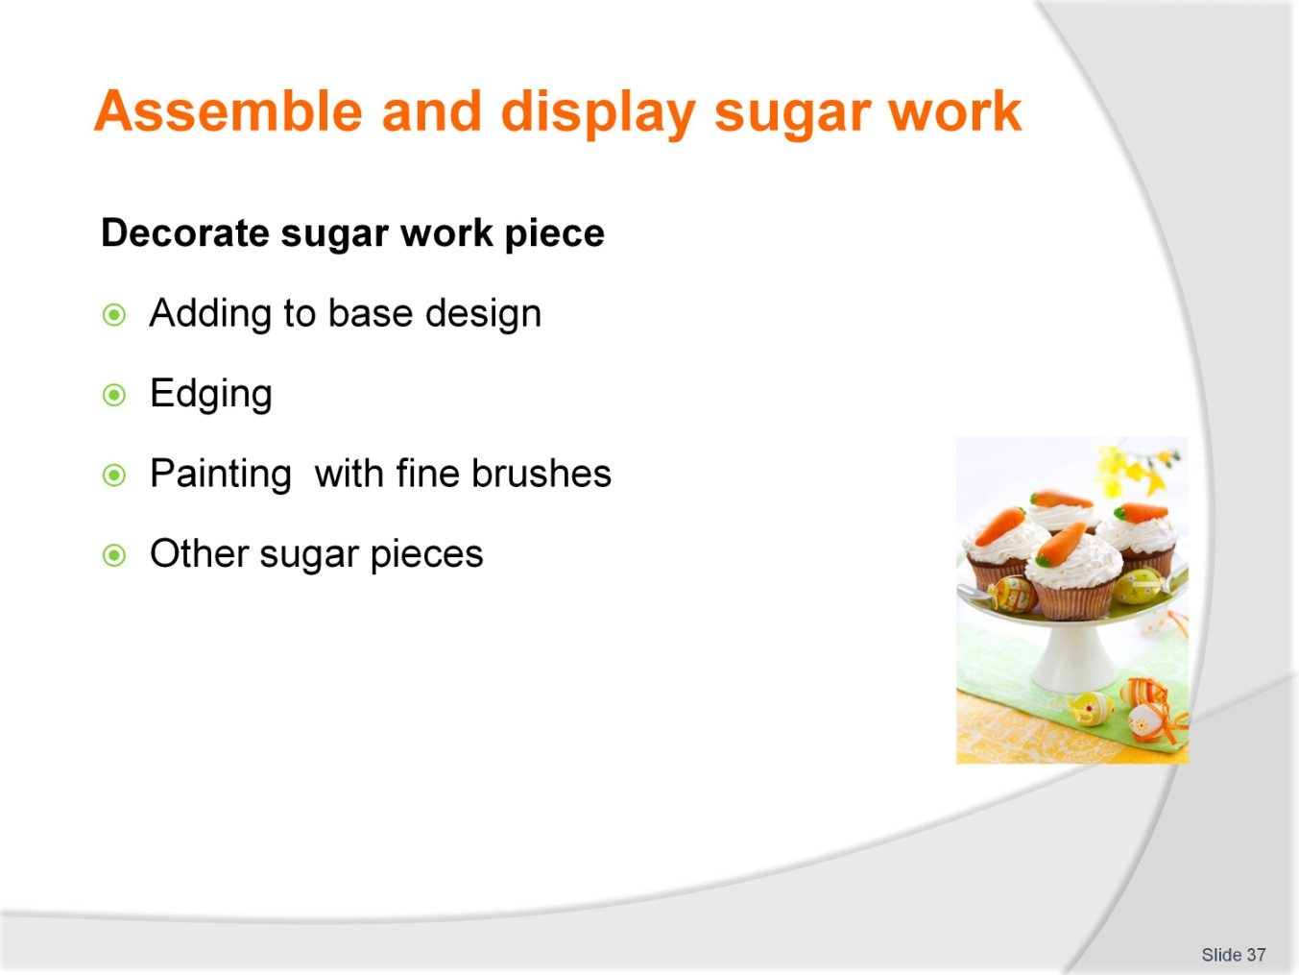
Slide No | Trainer Notes
Trainer to advise
Decoration of the sugar can be done after it has been assembled
Balls can be painted with food colours to produce faces
Smaller pieces of sugar can be melted and touched to other colours to show eyes, noses attached
Liquid colours can be sprayed to add lustre to the sugar surface.

Slide
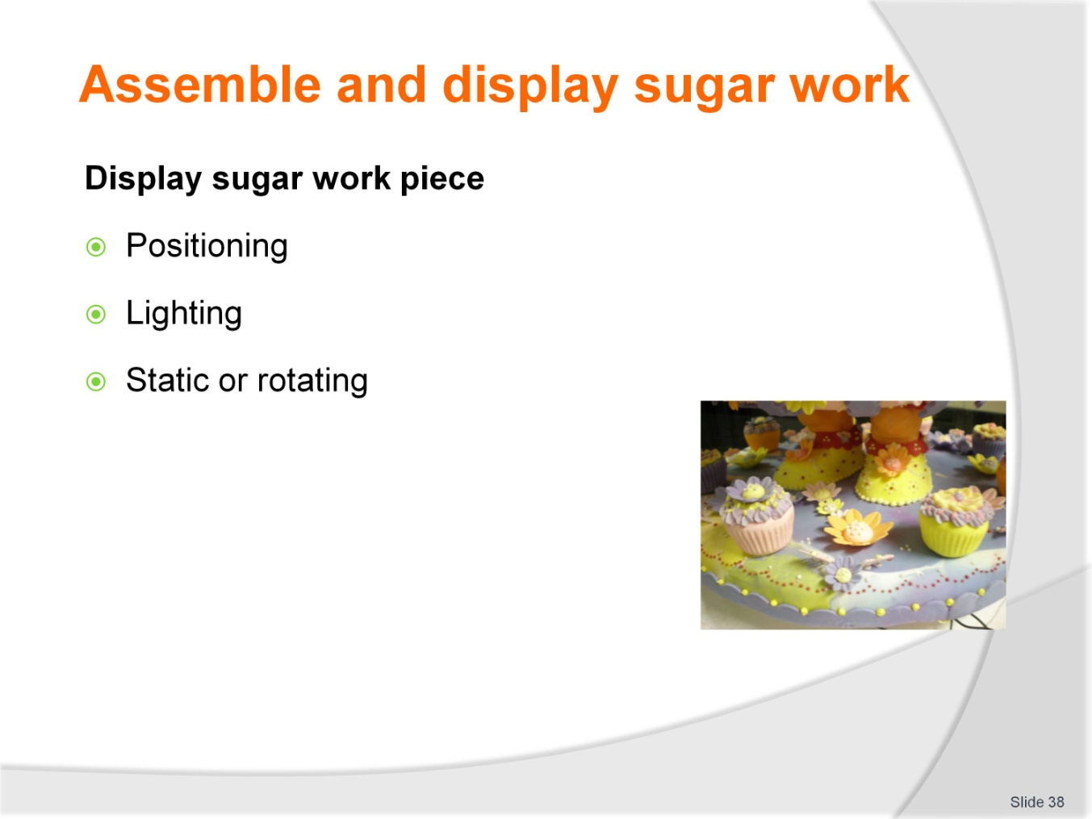
Slide No | Trainer Notes
Trainer to advise
There are many ways to show a sugar display
Behind protection shield
Static surface
Rotating base; requires electric motor
How will lighting be used to highlight piece.

Slide
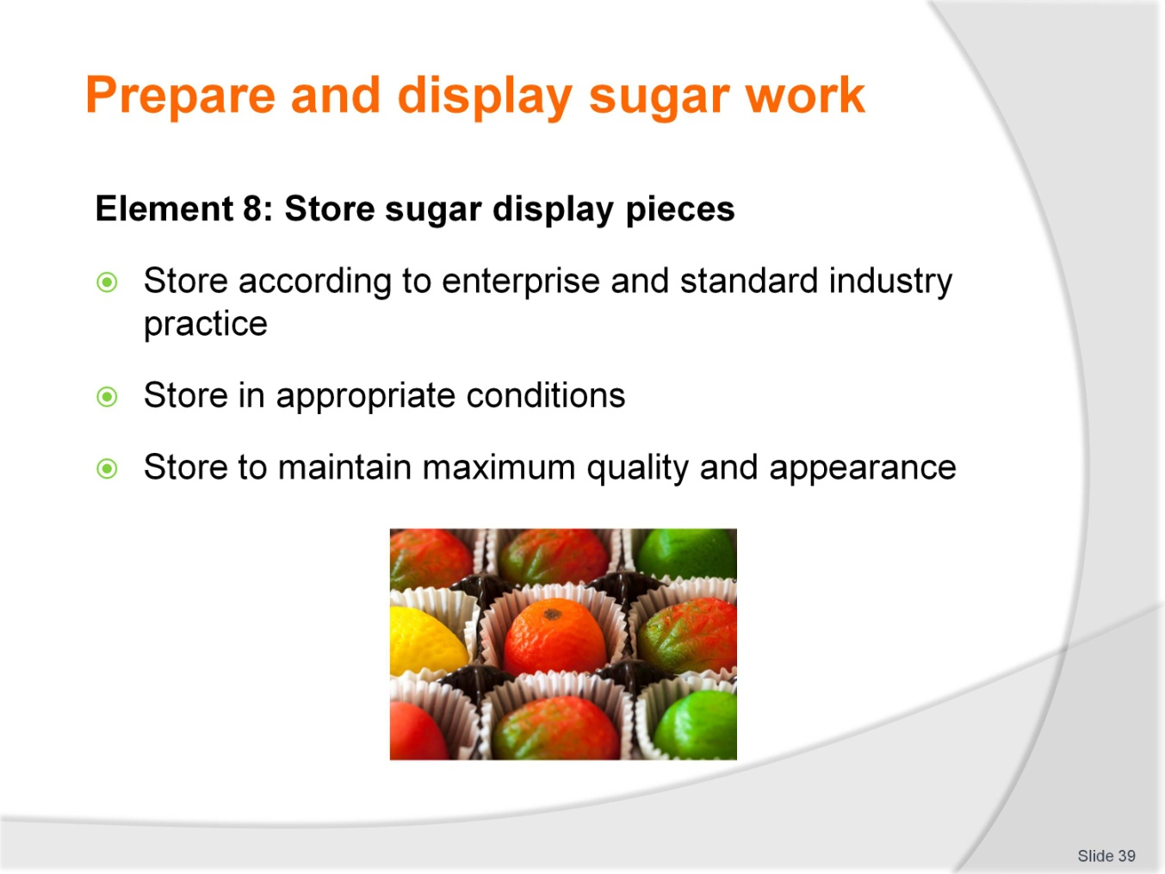
Slide No | Trainer Notes
Trainer to advise
Trainer to relate performance criteria to element 8
Performance criteria is the process by which the students training match the learning element
The element is the skill
To assess competency in the skill; the performance criteria is used to outline activities that can be used to assess competency.
The trainer should relate how the performance criteria is related to the element
To be able to Prepare and display sugar work the students must be able to; Store sugar display pieces
The student should be able to:
- Store according to enterprise and standard industry practice
- Store in appropriate conditions
- Store to maintain maximum quality and appearance.

Slide
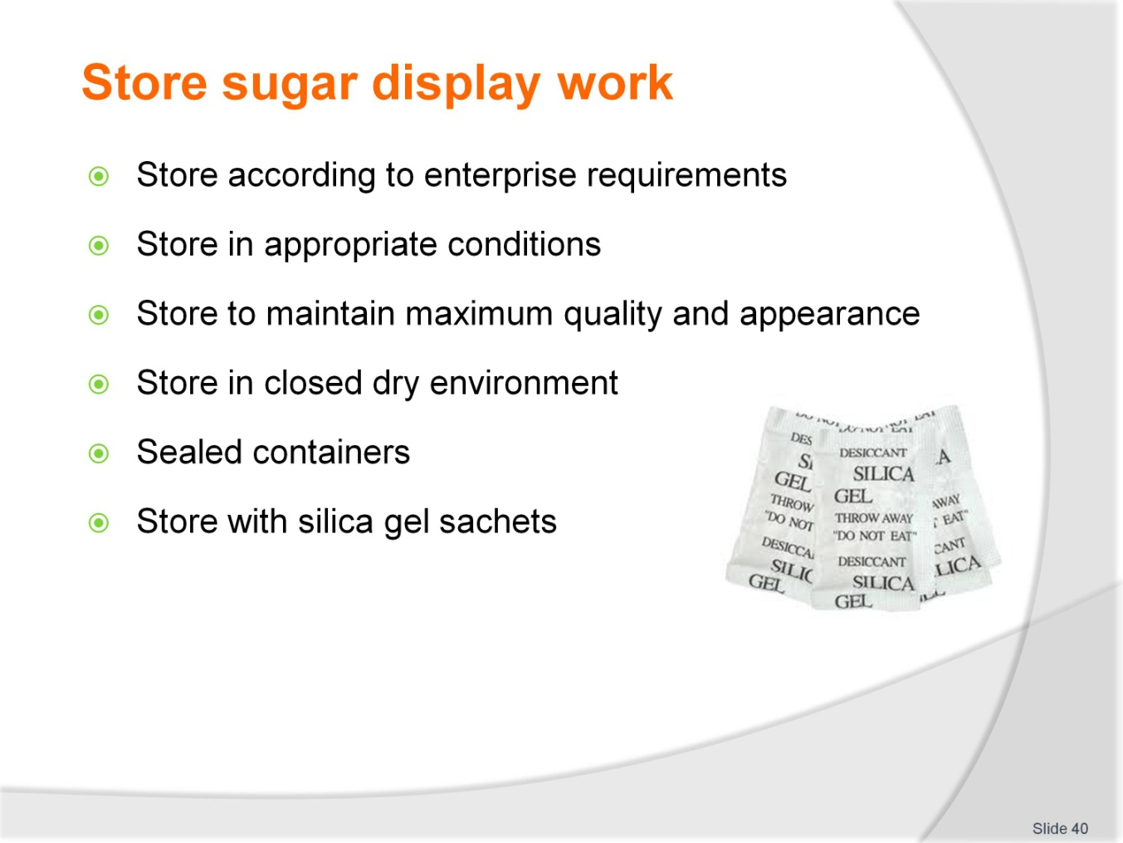
Slide No | Trainer Notes
Trainer to advise
Sugar works will not have a long life due to its hydroscopic properties
Isomalt is better for storage of finished sugar work.

Patisserie practical classes: Recommended training equipment
The equipment and kitchen consumables required for the delivery of practical patisserie training classes are listed below, in the following categories:
A Items of equipment which should be available for trainer and student use in the training kitchen.
B The cleaning equipment and cleaning products which should be available in a cleaning room located adjacent to the kitchen, so that students can clean down to leave the kitchen in “as found” condition at the end of each class or session.
C Consumables other than foodstuffs which need to kept in the kitchen and available for everyday use in each class or session.
D The items required by each student which would make up their own individual use kit of tools and small equipment.
A: Equipment in the training kitchen:
Baking ovens  Baking trays  Bakery racks for baking trays  Cooling wires  Proofers  Stainless steel benches or benches with washable surfaces  Stainless steel sinks  Dishwasher  Electronic scales or balance scales  Cake forms ,round and square, rectangular  Cooking pots of various sizes  Sugar work kit | Pie forms  Quiche forms  Measuring jugs  Rolling pins  Food storage containers large and small  Tartlet moulds  Brioche moulds  Pastry docker  Baking paper  Silicon baking sheets  Sieves for dry ingredients  Chocolate tempering kit
B: Cleaning equipment and consumables:
Scrubbing brush  Scourers  Sink plugs  Floor brooms  Small brush and shovel  Floor mop | Mop bucket  Rubbish bins  Detergent  Hand dishwashing detergent  Paper hand towel
C: Consumables (non-food) to be available in the kitchen:
Silicon baking paper  Plain white butchers paper  Greaseproof paper  Aluminium foil | Plastic wrap, clear  Plastic sheeting clear  Product boxes of various required sizes  Doyleys as required
D: Student equipment kit should include:
Cooks knife  Serrated edge knife for cake cutting  Pastry cutters, round and crinkled  Paring knife  Pastry brushes  Thermometers digital  Dough scrapers, plastic  Bench scrapers, metal  Piping bags, disposable or re-useable  Piping tubes, various sizes  Rubber spatulas  Pastry brushes  Pallet knives of various sizes | Angled Pallet knife  Measuring spoons  Measuring cups  Grater  Zester  Scissors  Carborundum sharpening stone  Balloon whisks of various sizes  Vegetable peeler  Serving spoons, perforated and non perforated  Tongs for handling foods  Marzipan shaping tools

Instructions for Trainers for using
PowerPoint – Presenter View
Connect your laptop or computer to your projector equipment as per manufacturers’ instructions.
In PowerPoint, on the Slide Show menu, click Set Up Show.
Under Multiple monitors, select the Show Presenter View check box.
In the Display slide show on list, click the monitor you want the slide show presentation to appear on.
Source: http://office.microsoft.com
Note:
In Presenter View:
You see your notes and have full control of the presentation
Your trainees only see the slide projected on to the screen
More Information
You can obtain more information on how to use PowerPoint from the Microsoft Online Help Centre, available at: http://office.microsoft.com/training/training.aspx?AssetID=RC011298761033
Note Regarding Currency of URLs
Please note that where references have been made to URLs in these training resources trainers will need to verify that the resource or document referred to is still current on the internet. Trainers should endeavour, where possible, to source similar alternative examples of material where it is found that either the website or the document in question is no longer available online.

Appendix – ASEAN acronyms
AADCP | ASEAN – Australia Development Cooperation Program.
ACCSTP | ASEAN Common Competency Standards for Tourism Professionals.
AEC | ASEAN Economic Community.
AMS | ASEAN Member States.
ASEAN | Association of Southeast Asian Nations.
ASEC | ASEAN Secretariat.
ATM | ASEAN Tourism Ministers.
ATPMC | ASEAN Tourism Professionals Monitoring Committee.
ATPRS | ASEAN Tourism Professional Registration System.
ATFTMD | ASEAN Task Force on Tourism Manpower Development.
CATC | Common ASEAN Tourism Curriculum.
MRA | Mutual Recognition Arrangement.
MTCO | Mekong Tourism Coordinating office.
NTO | National Tourism Organisation.
NTPB | National Tourism Professional Board.
RQFSRS | Regional Qualifications Framework and Skills Recognition System.
TPCB | Tourism Professional Certification Board.







